Topology and design: tools for reducing embodied carbon in steel-and-concrete floor layouts

Natasha K. Hirt, Caitlin T. Mueller

# 1. Motivation and background (1000-1500)

The world needs more, and more efficient buildings. Between 2006 and 2019, global built floor area increased by 65%, which the International Energy Agency (IEA) estimates will double by 2050. As construction accelerates to meet the needs of a larger population, so will the environmental effects of the building sector. Embodied carbon (EC), or the carbon dioxide equivalent emissions resulting from the extraction, processing, and manufacturing of building construction materials, currently accounts for approximately 7% of annual global carbon emissions.[1] To limit the climate impact of future construction, we require new construction methods that allow us to meet demand much more efficiently.

Flexural systems such as beams and slabs are prime candidates for innovation and improvement. These systems work in flexure, which is generally less efficient than other forms of load-bearing, and are repeated throughout the structure. As a result, floor slabs rank among a building’s most material-intensive components, constituting between 40–80% of the embodied energy of structures up to 80 stories.[2–4] Further, the mass of the floors affects the sizes of the columns and foundations required to support them, so lighter floors yield a lighter overall building.

Efficient floor slabs are not a uniquely modern idea. In general, precedents for efficient slab design have arisen whenever construction materials were in limited supply. For instance, a 1939 ban on steel reinforcement in Italy prompted radical explorations into new structural forms (steel was considered an anti-autarkic material).[5] Engineer and architect Pier Luigi Nervi excelled in this environment, developing new prefabrication and design methods for concrete and wire-mesh-reinforced ferrocement. His style is characterized by structural slabs and vaults whose ribs run not orthogonally, as is conventional, but flow along the isostatic lines of the structure (Figure 1a). The structural forms were determined using a combination of classical plate theory, strain gauge and photo-elastic experiments, and intuition, and allowed for the economical construction of large spans at a time of great scarcity.[6]

As technology and mathematical knowledge evolved, analytical methods have consistently found that better slab design has significant material savings potential. Morley’s instigating work in 1966,[7] which was further developed by Rozvany and collaborators in the following decades,[8] concerns itself with the minimum arrangement of steel reinforcement within concrete slabs so as to achieve optimal moment distributions. Bolbotowski et al. have verified Rozvany’s results computationally and generalized them to a wider range of load-dependent problems.[9] Despite the closed-form nature of the problem, its applicability to a range of boundary conditions, and the generality made possible by numerical methods, Morley’s early concern that the “necessary reinforcement arrangement is… too complex for practical use”[7] has proven true in standard construction practice.

Most recently, access to powerful computational tools has prompted renewed interest in optimal floor system design. In particular, the motivating environmental concerns have underscored the need for practical, readily implementable solutions. The two principal approaches to this challenge have been shaped beams and optimal beam layouts.[10]

In an investigation on shaped beams, Ismail et al. show that carving out underutilized material from a reinforced concrete (RC) beam can reduce its volume by up to 55%, [10] a result later replicated in timber.[11] Both of these materials can be cast or cut into the desired cross-section. Steel, which is the beam material discussed in this paper, has not been fully explored in the realm of shape optimization,[12] owing both to the efficient form of the conventional steel I-beam and to the difficulty of variably shaping hot-rolled steel.[13]

The second approach, optimal beam layouts, has several entry points, of which the most salient is continuum topology optimization across an entire slab.[14] By algorithmically iterating over a three-dimensional design domain, continuum topology optimization produces a complex pattern of concrete ribs bespoke to the loading and support conditions of that particular slab (Figure 1b).[15] Despite considerable material savings, the manufacture of nonstandard slabs is energy, material, and time-intensive, and a full life-cycle analysis would be necessary to evaluate their full environmental impact.[16] Alternative strategies for slab layout optimization include ground-structure topology optimization. Whiteley et al. used this method, which consists of varying the stiffness of members within a dense network until only the essential members remain, to guide the design of an RC concrete slab.[17] The optimization algorithm used minimized total structural volume within the constraints of compliance with Eurocode 2, and both nearest-neighbor and fully-connected networks were found to be suitable starting points. Hearkening back to Nervi’s methods for economical design, the suggested formwork for the resulting slab would be single-sided and reusable for slabs with identical boundary conditions. A later paper demonstrated the constructability of slabs Whiteley’s slabs, where laser-cut steel provided the necessary mechanism for variable reinforcement.[18]

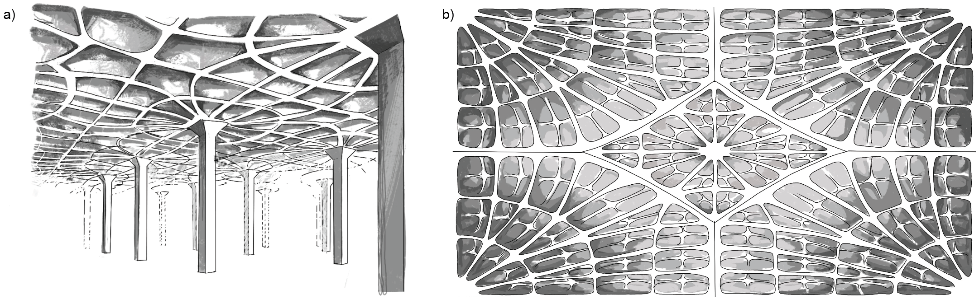

*Figure 1: Precedents for shaped slabs include a) the Gatti Wool Factory by Nervi,*[19] *and b) the 3D-sand-printed slab by Block Research Group.* [20] *Images by the author.*

## 1.1 Research gap, questions, and approach

In sum, both analytical and experimental evidence suggest that, when used, optimal flexural systems can significantly reduce the EC of buildings. Thus far, however, a generalized, code-compliant design strategy that leverages current construction methods has not emerged, leading to a separation between standard engineering practice and theoretically optimal systems.

This paper presents a method for analyzing and developing new slab geometries using computational tools. These tools allow the discovery of new, potentially nonobvious, structural configurations that are efficient, aesthetically pleasing, code-compliant, and use commercially available materials and construction methods. As such, it employs four out of Fang et al.’s thirteen design strategies for reducing structural EC. (0a Estimating EC from bottom-up quantities; 1: Exploring or optimizing the parametric design space; 3: Using less material; 9. Exploiting standardization and/or customization).[21]

Section 2 details an algorithmic method for designing slabs with nonstandard steel beam layouts. The slabs considered are flat reinforced concrete plates and supported by wide-flange (W) sections rolled out of A992 steel (E = 210GPa). The method generalizes and automates an engineer’s ability to size beams in an arbitrary, convex layout based on geometrically defined tributary areas. Despite their topological complexity, these grillages can be assembled using conventional steel construction techniques, using readily available structural elements.

Section 3.1 shows how the method can be used to accurately estimate the effect of different engineering and architectural detailing, or design decisions on the efficiency of the slab. In section 3.2 the same practice is applied to two distinct parametric design spaces, allowing us to map out the performance landscape for a range of continuously varying slabs. Given historical precedent and analytical outcomes, we anticipate that more complex topologies will perform more efficiently than standard forms. To that end, the following research questions are investigated:

* Which design decisions (section 2.2) are the most impactful drivers of efficient floor design?
* What trade-offs, if any, exist between different design decisions, including their impact on manufacturability?
* How sensitive is a given design space to changes in geometric parameters, keeping all else constant? How is performance affected by different combinations of design decisions?

# 2. Methodology: Automated embodied carbon assessment of beam-slab structural systems

## 2.1 Conceptual overview

The algorithm presented in this paper allows for the design, analysis, and sizing of beam layouts supporting RC slabs using a combination of vector-based geometric analysis and finite elements. The resulting RC slabs and steel sections are sized in accordance with ACI 318-19, ASCE 7-22, and AISC-16 design codes.[22–24] A summary diagram can be found in figure 2.

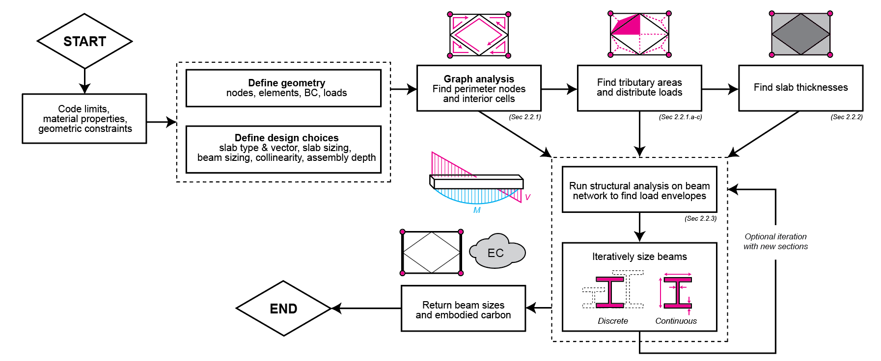

*Figure 2: Summary flowchart for automated analysis and sizing for irregular steel beam-and-RC slab layouts.*

The method follows the outline of a standard steel design workflow, modified for three different spanning systems. Slabs may be isotropic (section 2.2.1.a), uniaxial (section 2.2.1.b), or orthogonally biaxial (section 2.2.1.c) depending on the material and reinforcement choice. The choice of spanning system determines the maximum span of each cell in the layout (section 2.2.2) as well as the flow of load from the slab to individual beams. As floor slabs are indeterminate, the exact load distributions can only be approximated, but we can make an informed guess based on standard practices.

Finding specific load distributions depends on how the area of each cell of the slab, and the live and dead loads it carries, is subdivided between the beams on its perimeter. Subdividing the cells breaks the slab into tributary areas, each of which represents an area of slab that transfers forces to a given beam. When tributary areas are rectangular, the load can be considered uniformly distributed across the length of the beam. Polygonal tributary areas need to be treated more carefully, as more load may flow to some parts of the beam than others, so the strip method is used to assign point loads across the length of the beam.

Once the load distribution is found, the beams are sized according to their moment and shear envelopes. This also explains why a uniform load distribution should not be used for irregular tributary areas, as the specific assignment of loads affects its force envelope and therefore its sizing. We size beams with realistic algorithms that select the best option from a catalog of discrete ASCE W-sections as well as a more hypothetical, continuous sizing method (section 2.2.3).

To replicate the structural action of a frame in the finite element analysis (FEA), nodes designated as column connections are supported by stiff 1m-high columns. If no columns are designated by the user, the nodes on the perimeter of the slab are used. Column bases are fixed, while beam joints at column nodes are moment released. All other joints are moment connected unless manually released.

This method is written in Julia v1.9.3. FEA is performed using the package Asap.jl.[25] A single slab with 2x2 bays takes between one and two minutes to run on a local 2.3 GHz Quad-Core Intel Core i7 CPU. The full analysis of 12096 slab layouts was run in parallel on a headless CentOS Linux computing cluster.

## 2.2 Structural design decisions

The key design decisions used in this analysis are slab type (section 2.2.1), slab sizing (section 2.2.2), beam sizing (section 2.2.3), beam collinearity (section 2.2.4), and assembly depth (section 2.2.5). In general, one of the decisions aligns with standard practice, and the other is potentially more optimal but also more complicated to manufacture. The results of these pairwise comparison are shown in figure @ and discussed in section 3.1.

### 2.2.1 Slab type: load distribution and rebar layout

Slab type is determined by the material as well as the reinforcement layout of the slab and is a prerequisite for understanding the flow of forces in a slab. An isotropic slab allows loads to flow in all directions equally, allowing loads to utilize the shortest path to load-bearing elements (Figure 3a). Such a slab might be made of metal or another material that has uniform properties in all directions. In concrete, reinforcement typically constrains the directions in which loads can flow. Rebar may be laid in one or more directions, with the two primary slab types being uniaxial (Figure 3b) and biaxial orthogonal (Figure 3c). In the former case, rebar is laid in one direction only, while in the other case rebar is laid in both, forming a grillage. In rectangular slabs, slabs with cells whose length is twice their width are often uniaxial, whereas more square slabs are biaxial. Although grillages are commonly orthogonal to the slab direction, as this simplifies construction, other, diagonal arrangements are also possible.

@ add something about construction

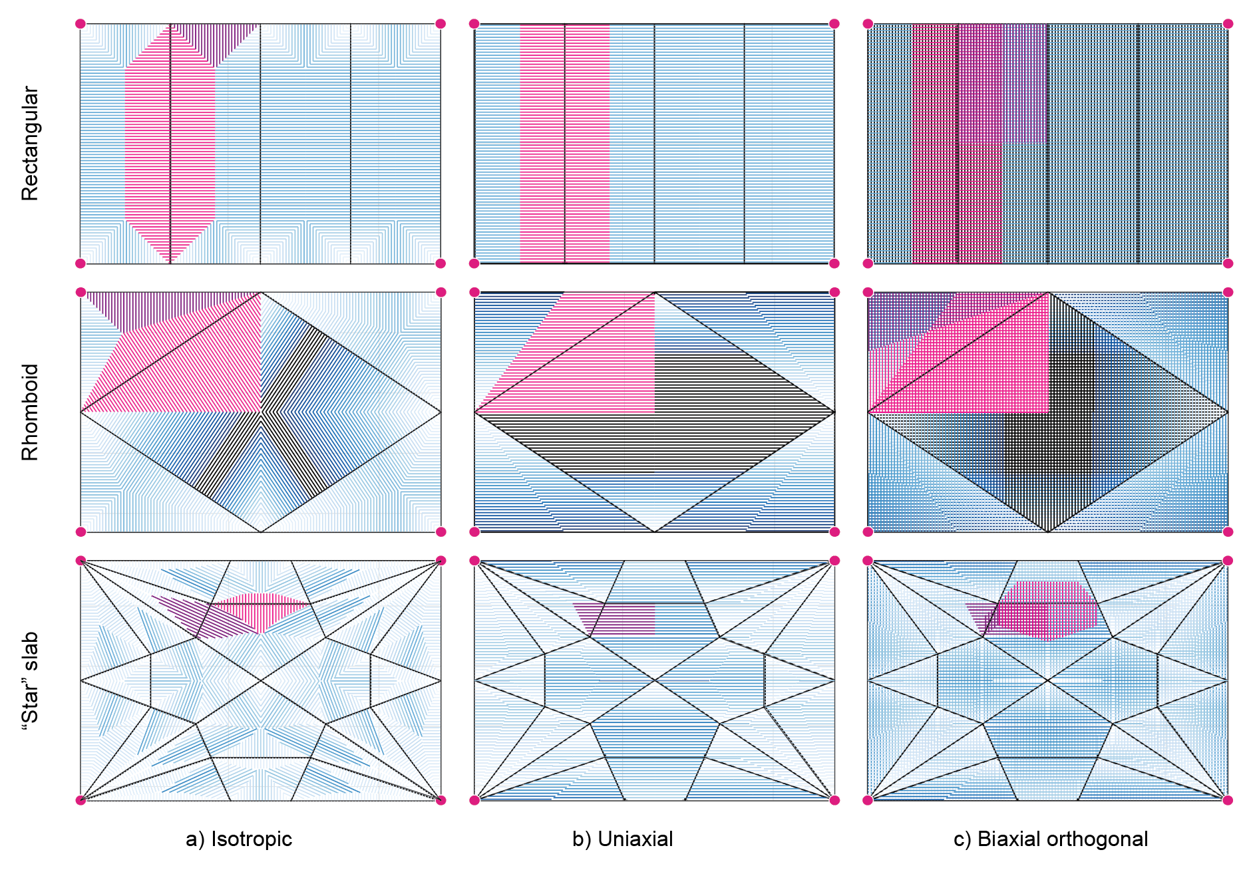

*Figure 3: Tributary areas defined for a) isotropic, b) uniaxial, and c) biaxial orthogonal slab types for a conventional (rectangular) as well as two more unconventional layouts. The vector direction of the uniaxial and biaxial orthogonal slabs is [1.,0.], while the load vectors of the isotropic slab are determined by the normal vectors of the boundary beams.*

The beam layout is initially inputted as a standard finite-element model (FEM). These describe of nodes, elements, loads, and supports. The nodes and elements are translated into a graph of nodes and edges. The data structures are backward compatible with the original FEM but are more easily manipulated with established computational methods. One of these, a convex hull algorithm, is used to find the perimeter nodes of the graph. Convex shapes are not permitted by the algorithm, either on the interior, for the cells, or the exterior, for the hull. If a hull is nonconvex, the algorithm inserts a new edge to achieve convexity on the perimeter. Interior cell convexity is considered invalid.

Once the perimeter of the slab is established, a minimum cycles algorithm is used to find the interior cells of the graph. Cells are defined by a closed loop of beams and constitute the primary unit of analysis for the remainder of the method. First, half-edges are assigned to each beam depending on whether it is known to be a perimeter beam from the previous step (figure 4a). Perimeter beams are adjacent to one cell, and therefore receive one half-edge (1), whereas non-perimeter beams are adjacent to two and have two half-edges (1, -1). The half-edge relationships are captured in a connectivity matrix, from which they are converted into a list of adjacencies (figure 4b). Iterating over the adjacencies traces out the cells. For example, node A is connected to B, B to E, and E to A. The cells ABE closes once A is reached again, and the adjacencies used are removed from the dictionary. The process is repeated for BCDE. Once all minimum cycles are traversed, the adjacency dictionary is empty, and the algorithm returns the cells.

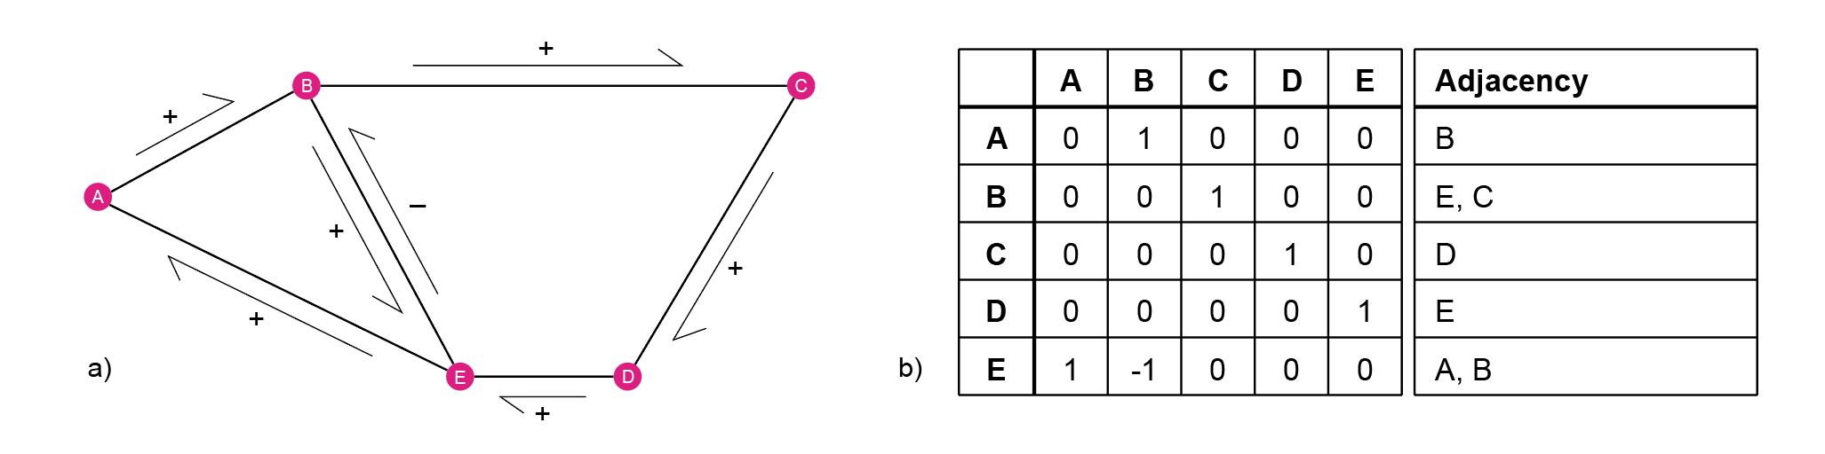

*Figure 4: The geometric and graph representations of a sample beam layout.*

Currently, only convex networks can be analyzed in this manner. This constraint is structural: a convex corner in a beam network is likely to undergo large torsional deformations without contributing to the load-carrying capacity of the structure. Nonconvex cells in the beam network are therefore invalid, and the slab is not analyzed.

Analyzing the FEM as a graph allows for a rapid evaluation of the planar beam layout while accepting standard inputs. The derived geometric information forms a foundation upon which vector methods to find tributary areas and load distributions are based.

Point loads are assigned by multiplying the area of the strip calculated in the following sections 2.3-2.5 by the sum of the unit dead load of the slab found in section 2.6, and the design loads. Live loads are assumed to be 30psf (1.44 kN/m3), and dead loads 50psf (2.39 kN/m3).[24]

#### 2.2.1.a Isotropic tributary areas

Loads in an isotropic slab flow equally easily in all directions (figure 5a). In standard practice, it is assumed that under such circumstances, loads will flow to the nearest beam along a path normal to the beam. One approach is to discretize the cell into small squares, find the closest perpendicular point on each perimeter beam to a givensquare, and assign its load to the nearest beam at that point. This rasterization method is intuitive but somewhat redundant, as all the squares along the same load path would need to be assigned individually. Additionally, compute increases quadratically for a grid with a finer raster, making it challenging to increase resolution.

A more reasonable approach would be to perform vector calculations only when necessary. Instead of working with individual squares, we find an entire load path of some width *s* along a vector normal to the beam, then assign its area multiplied by the slab loads as a point load. The primary challenge with this approach is to find a sensible tributary area subdivision, the boundary of which tells us where to terminate the load path. Once it is found, the strip method is used to divide the tributary area into load paths. Empirical tests conducted by the authors showed that the 0.1m spacing between strips is sufficient for convergence.

The complexity of finding the tributary area depends on the geometry and irregularity of the cell. In an equilateral triangle, simply drawing bisectors from each corner produces a single intersection point and three equal-area subdivisions. However, in an irregular polygon, two bisectors will often intersect before any others. In figure @a, for instance, the bisectors of the quadrilateral almost meet, but a slight irregularity instead produces two distinct intersections. If there are only two intersections, a line can be drawn between them to complete the tributary areas. However, for higher-order polygons, there may be three or more intersections, creating an inner, lower-order polygon that needs to be further subdivided. To find the tributary areas we recurse over the inner polygons until either one or two intersections are reached. Once a base case is found, the tributary areas are reconstructed.

This method is specific to bisectors. For more complex subdivisions, such as ones determined by the stiffness of the individual beams, another approach is required. Stiffer beams attract more load than relatively more flexible beams, so it has a greater tributary area. As the bisector approach creates unresolvable intersections when the angles are changed, we instead use a weighted wavefront progression.[26] In a typical wavefront progression, each edge is offset by unit distance, emulating ripples. The intersection events are solved, and the process is repeated until all wavefronts converge. To solve for tributary areas, the relative stiffnesses of the beams are analyzed ($S_{rel}=\frac{EI}{L^{3}}$), and a set of corresponding subdivision vectors is produced. Each corner point is translated along that vector by unit distance. Connecting the points creates a new polygon, which shrinks with every iteration until convergence is reached.

There is no obvious answer for where the forces flow in an indeterminate, isotropic slab, so both approaches are approximations. For most of the following analysis (section 3), the bisector method is chosen as it more closely resembles the standard methods used by engineers in practice. A direct comparison between the outcomes of the bisector and the stiffness-driven approach is presented in figure 6.

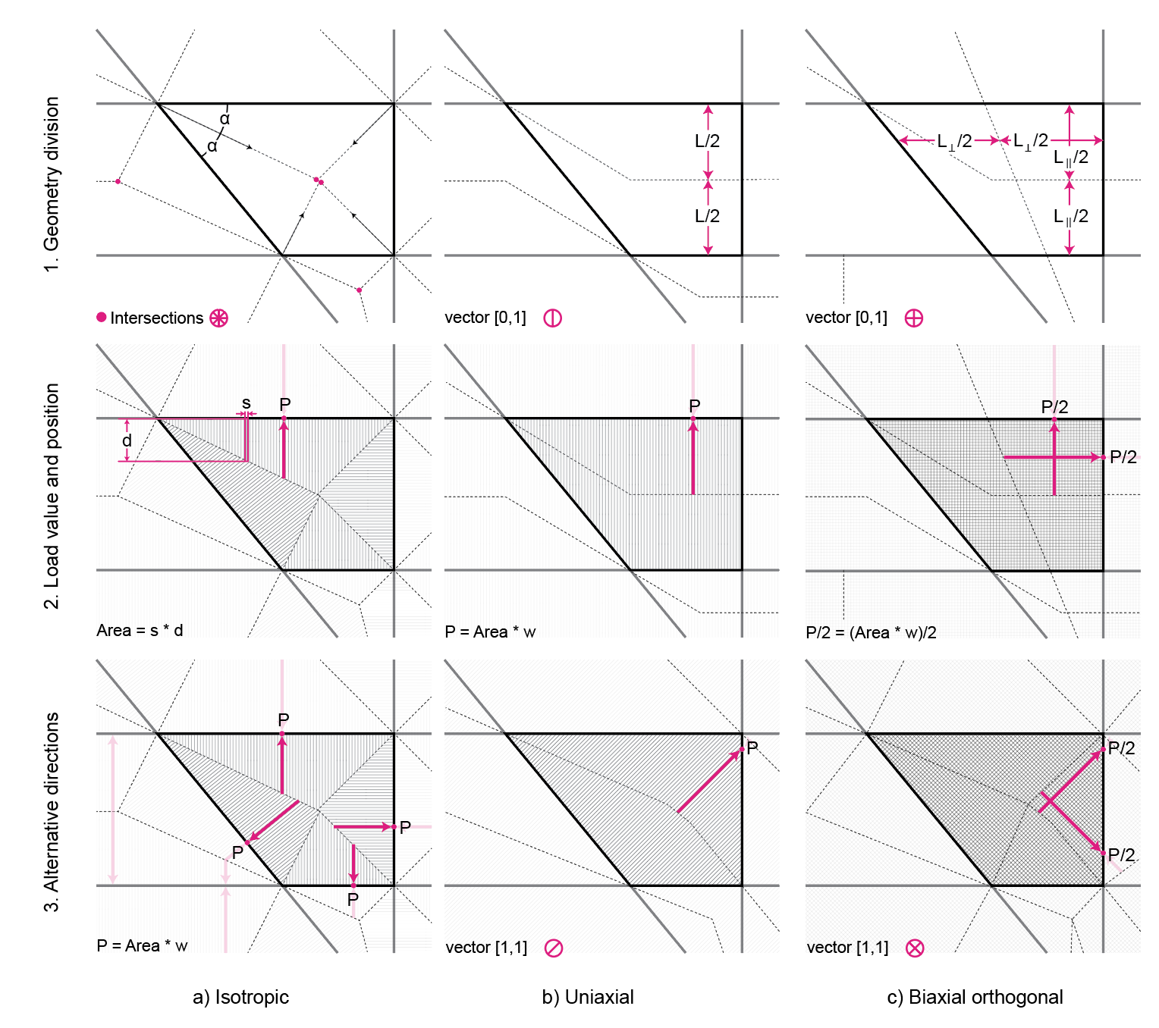

*Figure 5: Close-up representations of the vector analysis performed to find the tributary areas and load distributions for an a) isotropic, b) uniaxial, and c) biaxial orthogonal slab cell. Step 2 shows orthogonal reinforcement for the uniaxial and biaxial slabs, while Step 3 shows the results of an alternative analysis with diagonal reinforcement.*

#### 2.2.1.b Uniaxial tributary areas

Uniaxial slabs only transfer load in the direction of reinforcement (figure 5b). Vectors are projected along this direction from each beam in a cell, at intervals with spacing *s*. Those projected into the interior of the cell intersect with the opposite side of the cell, and their intersection point is recorded. Those that do not intersect are discarded, as they point to the exterior. The outcome is a trimmed vector field inside the cell. The length of each trimmed projection is halved and converted to a point load at the point of intersection.

If stiffness is a consideration, the projection is not halved but partitioned according to the relative stiffnesses of the intersecting beams.

#### 2.2.1.c Biaxial orthogonal tributary areas

Biaxial orthogonal slabs transfer loads along both directions of orthogonal reinforcement (figure 5c). We use a superposition of uniaxial analysis in both vector directions, where each uniaxial direction is accorded 50% of the total load of the slab. Stiffness-specific modifications are applied independently along each orthogonal vector.

### 2.2.2 Slab sizing: maximum span and slab depth

The maximum span of a cell determines its depth. The ACI 318 required minimum depth for deflection control of one-way (uniaxial) continuous slabs is $l_{n}/28$, and for two-way (biaxial) interior slabs without drop panels it is $l_{n}/36$, where $l_{n}$ is the maximum effective span of the slab.[22] Isotropic and biaxial orthogonal slabs are both treated as two-way slabs. The absolute minimum in all cases is 0.125m, to allow enough room for rebar. If a maximum span exceeds the allowable span for that slab type (13.6m for an isotropic or biaxial slab, and 12.5m for a uniaxial slab), it is infeasible.

The maximum span of a cell in an isotropic slab is found by projecting the normal vector of each beam from each corner in the cell (figure 7a), selected because geometric extrema will always be found at the corners.[27] As in section 2.2.1.b, if an intersection is found, the vector is on the interior and its length recorded. The maximum length of both trimmed vectors and beam lengths gives the maximum span (figure 7b). A similar test is performed for the uniaxial slab, but the slab’s load-carrying vector is used in place of normal vectors. For the biaxial orthogonal slab, both vector directions are examined.

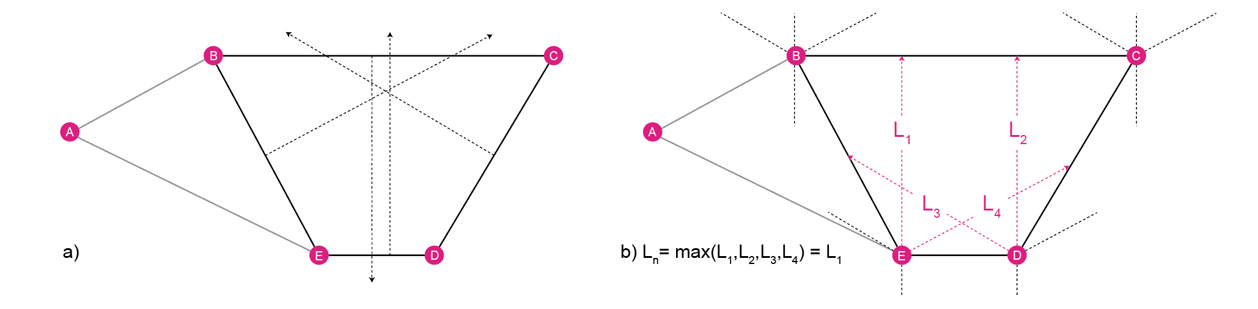

*Figure 7: Using corner-to-edge vectors to find the maximum spans of arbitrary cell geometries.*

As maximum spans are determined on a cell-by-cell basis, the ultimate slab depth can be calculated uniformly or cellularly. A cellular slab retains slab depths on a cell-by-cell basis whereas a uniform slab takes the maximum calculated slab depth and applies it to all the cells. The uniform slab requires less formwork and closer resembles conventional construction, whereas the cellular slab removes unnecessary material.

The mass of the slab equal to its depth multiplied by its unit area and the density of concrete (2400kg/m3). To convert to kN/m3, this value is multiplied by *g* (9.81m/s2).

### 2.2.3 Beam sizing: continuous and catalog-based optimization

An optimal section is the minimum area section whose moment and shear capacity exceed the nominal moment and shear forces, multiplied by a safety factor, at every point along the beam. It may not exceed the maximum deflection limit of $L/360$, where $L$ is the length of the beam.[23] Two methods are used to size the beams in this paper: discretely by selecting from the AISC W-section catalog, and continuously by varying section parameters within an allowable range. @all the beams are moment connected, further discussion in section@

Displacement is checked by inputting the new section values into the FEM and checking the local vertical displacement of the element.

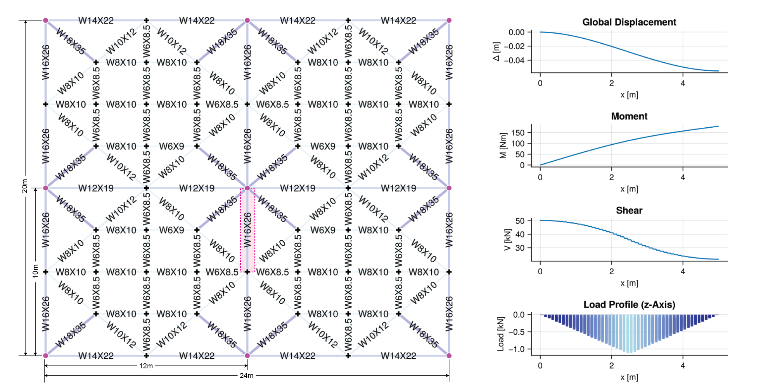

*Figure 8: Sections for an isotropic beam layout alongside displacement, moment, shear, and vertical load profile for a selected beam (W16X26).*

To size the beams discretely, the available sections are first sorted from smallest to largest (W4X13 to W43X335). The frame is analyzed using a flat sizing of W8X35 across all beams to find the load envelopes. Subsequently, each section in the catalog is checked against the load envelopes and deflection limits and added to a list of viable sections. The objective value is the sum of beam volume and deflection penalty, the latter of which is imposed when a beam deflects excessively.[12]

The section with the best objective value is chosen from the list of possible sections as the optimal section. The pseudocode is given below.

|  |
| --- |
| *Pseudocode 1: Discrete Section Sizing* |
| ϕb = ϕv = 0.9  serviceability limit = 360  **maximum displacement** = **beam length** / serviceability limit  objective values = []  valid sections = [] |
| *for* each **section** in **section catalog**  **beam volume** = **section area** * **beam length**  *if* **section depth** > **maximum assembly depth – slab depth**  *continue*  *elseif* absolute (**section Mu**) < ϕb * **Mn**  *continue*  *elseif* absolute (**section Vu**) < ϕv * **Vn**  *continue*  *else*  check **local** **displacement**  *if* **local displacement** > **maximum displacement**  **penalty** = (**local displacement** – **maximum displacement**)2 * 104  *else*  **penalty** = 0  *end*  **objective value** = **beam volume** + **penalty**  *end*  *append* (objective values, **objective value**)  *append* (valid sections, **section**)  *end*  **optimal section** = valid sections [*minimum index* (objective values) ] |

The second method for sizing sections is to treat the individual design parameters controlling section depth, flange width, flange thickness, and web thickness as continuous variables for optimization. In addition to the load and deflection constraints, geometric constraints are added in accordance with AISC:

1. Area > 0
2. 2 * flange thickness ≤ section depth @ make this look more mathy
3. Web area / compression flange area ≤ 10
4. Section depth / web thickness ≤ 260
5. 0.1 ≤ moment of inertia of compression flange / moment of inertia of section ≤ 0.9

Unlike discrete optimization, which is limited by the range of the catalog, the continuous variables can diminish to small nonzero values. As the constraints and objectives are differentiable, it is possible to do a local gradient-based optimization using the CCSAQ algorithm, which converges faster than non-gradient-based methods. CCSAQ is a relative of the method of moving asymptotes (MMA) commonly used in structural optimization but uses local quadratic approximation instead of MMA’s more complex convex approximation, which the authors found was more susceptible to falling into local minima than CCSAQ.[28,29]

Further, the continuous analysis is initialized with the output of the discrete analysis, which acts as a ceiling. To prevent unnecessary repetition in symmetrical slabs, beams with duplicate load envelopes are sized using previously found solutions.

Since the initial frame is populated with arbitrary sections (W8X35), it can be productive to perform additional iterations for both discrete and continuous optimization, where the frame is re-initialized with the list of optimal sections. Although only a single iteration is used for the following results, slight improvements can be seen in the continuous case after two to three iterations, whereas iteration has little to no effect in the discrete case.

### 2.2.4 Beam collinearity: varying beam depths

Uniform beam depths across collinear members can be imposed in post-processing, where all members that are exactly collinear are assigned their maximum section. This reflects the standard practice of using monolithic beams for longer spans and connecting perpendicular members to them directly rather than dividing the beam into several shorter members in a bid to achieve optimal section sizes. This reduces the number of connections and therefore the assembly process.

@write pseudocode

### 2.2.5 Assembly depth: slab and beam

The final design decision affects the maximum total depth of the slab and beam assembly. This is implemented as a constraint during optimization (section 2.1.3). The assembly depth is defined as the sum of the maximum slab depth across all cells and the maximum beam depth in the slab. Maximum assembly depth is often driven by architectural decisions which require a certain ceiling height, and typically comes at the cost of efficiency as deeper beams can carry loads more effectively.

## 2.3 Beam topology

Each slab in the dataset is designed as a continuous four-slab system with nine columns, of which eight are on the perimeter and one in the center. Individual slabs are 10mx12m, making the full assembly 20mx24m.

The slab layouts tested are designed in two dimensions in Rhino and automatically converted into a JSON format compatible with FEM. An example is provided in Appendix @. Three sets of layouts were created for this paper. The first set of layouts consists of geometrically distinct topologies and is manually designed. It includes symmetrical, asymmetrical, and business-as-usual layouts. The other two sets are parametric and vary along two dimensions. They are based on a grid-shaped layout and a star-shaped layout, the latter of which is inspired by Nervi. An instance of both the grid and star layouts is present in the topology set.

The grid layouts are based on waffle slabs. The number of beams running in the x and y directions, respectively, is tested between 0 and 5 to find the optimal density of steel beams, beyond which the mass of added steel outweighs the benefits of slimmer slabs.

The star layouts are designed to find the best arrangement of force-following beams. Precedents that use principal moments frequently rely on manual adjustment to determine the optimal position for ribs, since there are infinite possible load lines one might follow or are fully topology optimized and therefore difficult to manufacture (section 1). The design begins with a cross, which is augmented with beams connecting from the centers of the primary beams to the cross-beams at some parameter y, and beams connecting adjacent corners extending some parameter x toward the center. The higher the x-parameter, the sharper the corners of the star. In combination, the parameters produce star-shaped beams that discretely follow the load lines of the slab. The goal is to find which is optimal.

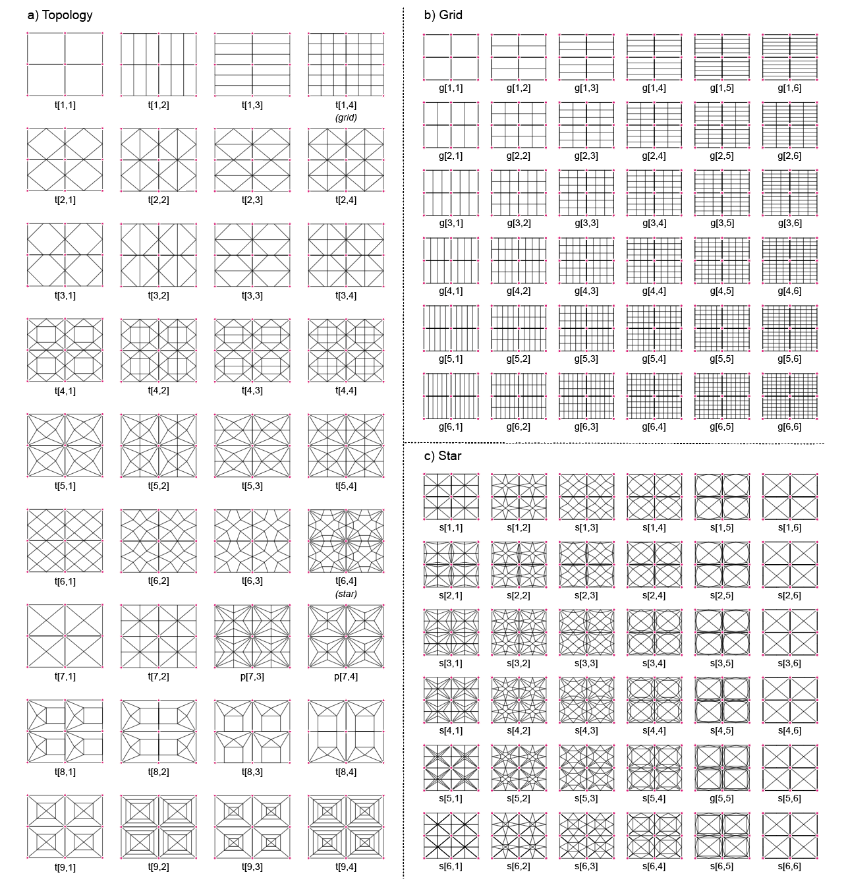

## 2.4 Summary

Established process to arbitrary beam layouts, detailing decisions, output embodied carbon due to steel beams rc slab and rebar

This paper aims to answer @ questions. (paraphrase) To answer the questions posed in section 1,

12096 slabs were individually simulated and sized. 36 slabs were selected from each of the topology (“t”), star (“s”), and grid (“g”) layout sets (section 2.3). The slabs were analyzed under combinations of different design choices, including slab type and vector orientation (7 variations), slab depth (2 variations), beam optimization (2 variations), beam collinearity (2 variations), and maximum depth (2 variations). $\left(\left(36 + 36 + 36\right)×7×2×2×2×2 = 12096\right)$. Of these, 11558 were viable and ultimately included in the analysis.

@ put this before the results/summary at the end of the method

|  |  |  |  |  |
| --- | --- | --- | --- | --- |
| **Design detail** | **Conventional** | **Symbol** | **Lower-carbon** | **Symbol** |
| **Slab sizing** | Uniform | u | Cellular | c |
| **Beam sizing** | Catalog | W | Continuous | c |
| **Beam collinearity** | Collinear | c | Noncollinear | n |
| **Assembly depth** | 25” | 25 | 40” | 40 |

|  |  |  |  |  |  |  |
| --- | --- | --- | --- | --- | --- | --- |
| **Slab type** | Isotropic | ✵ | Biaxial orthogonal | ✚ | Uniaxial | ━ |

Table @: Summary of pairwise comparisons corresponding to figure @.

### 2.4.1 Business-as-usual (B-a-U)

Picture and drawing

The slabs are compared to the “business-as-usual” slab (Table @), the position of which is demarcated by dashed lines. The horizontal lines show its steel and slab EC values, (60.28 kgCO2/m2 and 53.71 kgCO2/m2, respectively) whereas the diagonal line represents the line of constant embodied carbon equivalent to the business-as-usual slab (114.23 kgCO2/m2). The slab is based on the t[1,2] geometry (figure @) with a uniaxial slab, discrete sizing, and collinear beams. The slab follows a typical design of primary beams and parallel secondary beams oriented along the shorter span of the rectangular bays. Reinforcement in turn is oriented in the [1.,0.] direction, aligning with the span between secondary beams, and the maximum allowed assembly depth is 40”. 88.9% of the slabs in the dataset perform better than the business-as-usual slab (figure @c), an improvement achieved through a combination of better topology and design detailing choices.

# 3.0 Results

This section presents results from the 11558 slabs through a variety of data visualizations to produce granular and generalized knowledge about the design decisions and construction techniques that impact embodied carbon in RC slabs supported by steel layouts. First the d@@@ summary of section and how it is structured

## 3.1 Design and detailing decisions

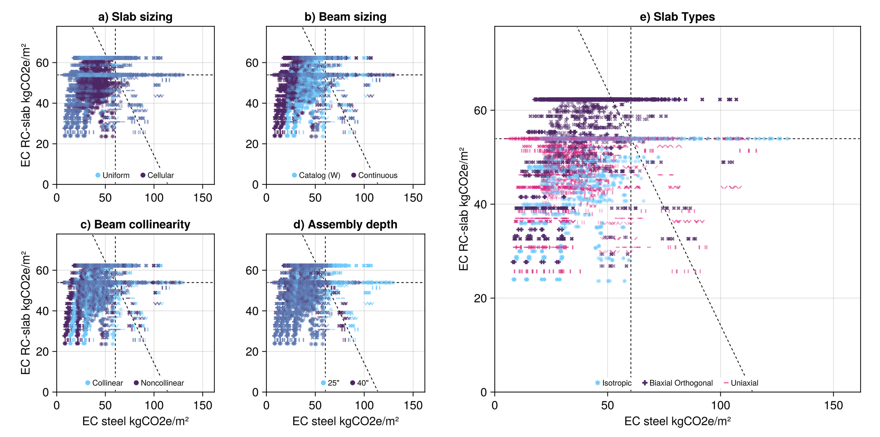

*Figure @: Multiplot showing pairwise comparisons for each of the design decisions a) slab sizing, b) beam sizing, c) beam collinearity, d) assembly depth, and e) slab types. Other than e), the plots contrast a business-as-usual choice in dark purple with a more optimal choice in light blue. Dotted lines indicate the performance of a business-as-usual slab with typical topology.*

Fix the aspect ratio + write B-a-U EC total/steel/slab on the dotted lines

Symbols are defined in section e and refer to the slab type

The results showing the impact of different design decisions are shown above. Figures @a-@d highlight pairwise comparisons between the normalized EC of the conventional and optimal variations of a) slab sizing, b) beam optimization, c) beam collinearity, and d) assembly depth, whereas figure @e compares different slab types and vector orientations. Table @ breaks down the mean and standard deviations for each comparison.

The EC of each floor slab is divided into the contributions from steel (x-axis) and slab (y-axis). Steel EC comes from the steel beams of the layout, excluding connections. Slab EC includes both concrete and rebar, where rebar is assumed to constitute 1% of the total slab volume in isotropic and uniaxial slabs, and 2% for biaxial orthogonal since the rebar is laid out in a two-directional grid. The volume of the rebar is increased by 5% to account for turnups and cutoffs.

Figure @ shows us the mean and quartiles of the pairwise comparisons. Although lower-carbon solutions do show modest improvements in slab efficiency over conventional construction, they likely do not warrant cost and complexity of implementing them.

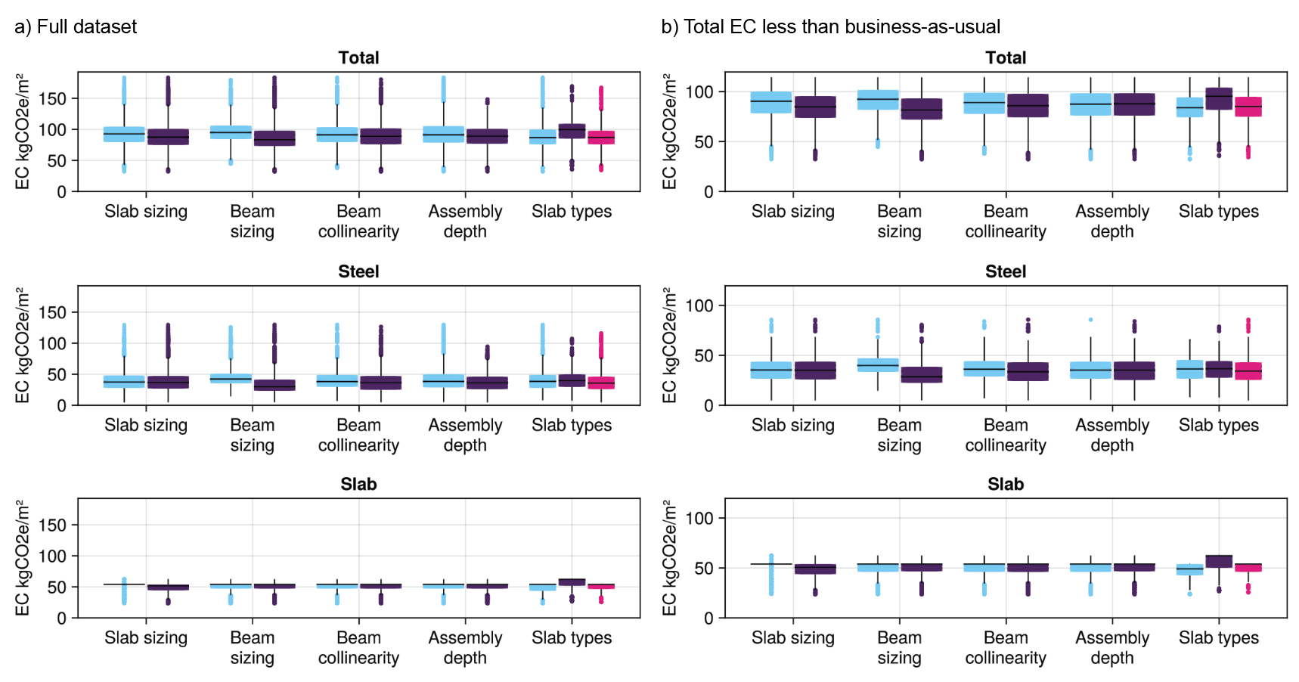

*Figure @: Box-and-whisker plots showing a) summary statistics for the full dataset (11446 slabs) and b) the dataset filtered to only show results better than the business-as-usual (8650 slabs). These values correspond to the results numerically presented in tables @ and @.*

### 3.1.1 Slab sizing

Slab sizing has an impact on concrete quantity and steel quantity, leading to cellular slabs having 4% less total EC than uniformly sized slabs (Section 2.2.2). The finer gradation of slab depths uses less concrete which in turn imposes lighter loads on the beam layout, allowing for smaller steel sections.

Higher EC slabs see more savings from the cellular slabs, while the improvement is marginal for slabs that already have low EC. Slabs that start with relatively high steel and low concrete quantities see a greater reduction in concrete than steel, particularly for beams sized using the catalog, suggesting that minimum beam sizes in the catalog are a limit on how little material can be used to support the slab. Figure @ supports this finding, as one of the most frequently used beam sizes is W6x8.5, which is also the smallest utilized size.

The uniform slab results form two large horizontal bands, one at the business-as-usual slab EC line, and the other slightly above. They are likely caused by the maximum possible span for the test slabs. Since each slab measures 10mx12m, all uniform slabs with a 12m span will have the same slab thickness throughout and are therefore arranged along the same line. Smaller bands occur for the 10m maximum span in the shorter direction but are less pronounced, as there are fewer slabs that have a 10m span and not a 12m span. 10m maximum span slabs include t[3,2], g[1,5], and 12m maximum span slabs include t[3,3], t[7,4], t[9,3], g[4,1].

The two distinct bands are caused by the same phenomenon; however, the upper band is shifted toward higher slab EC to account for the higher percentage of rebar in the biaxial orthogonal slabs. One can see from figure @e that the lower band is populated primarily by uniaxial and isotropic slabs.

Overall, cellular slab sizing is an effective way of reducing the EC of floor systems, though in practice it is likely not a cost-effective solution. The formwork, the EC of which is outside the scope of this analysis, could also outweigh the carbon savings of the slab itself, particularly if non-reusable. Prefabricated elements could play a significant role in improving the manufacturability and sustainability of this strategy.

### 3.1.2 Beam sizing

Figure @b shows the difference between discretely and continuous beam sizing (section 2.2.3). Since this parameter only affects the steel after slab loads have been applied to it, the shift direction is horizontal, toward lower steel EC, while slab EC remains the same. The change in efficiency suggests that the catalog is slightly oversized relative to the load demands on the slabs. It also suggests that several beams in the examined topologies may be so small as to be noncritical. A topology optimization approach could be implemented to remove these beams and allow larger, more significant beams to carry their loads.

This design decision is the most singularly impactful factor of those tested, with a 10.4% reduction across all slabs and an 10.1% difference for slabs lighter than business-as-usual.

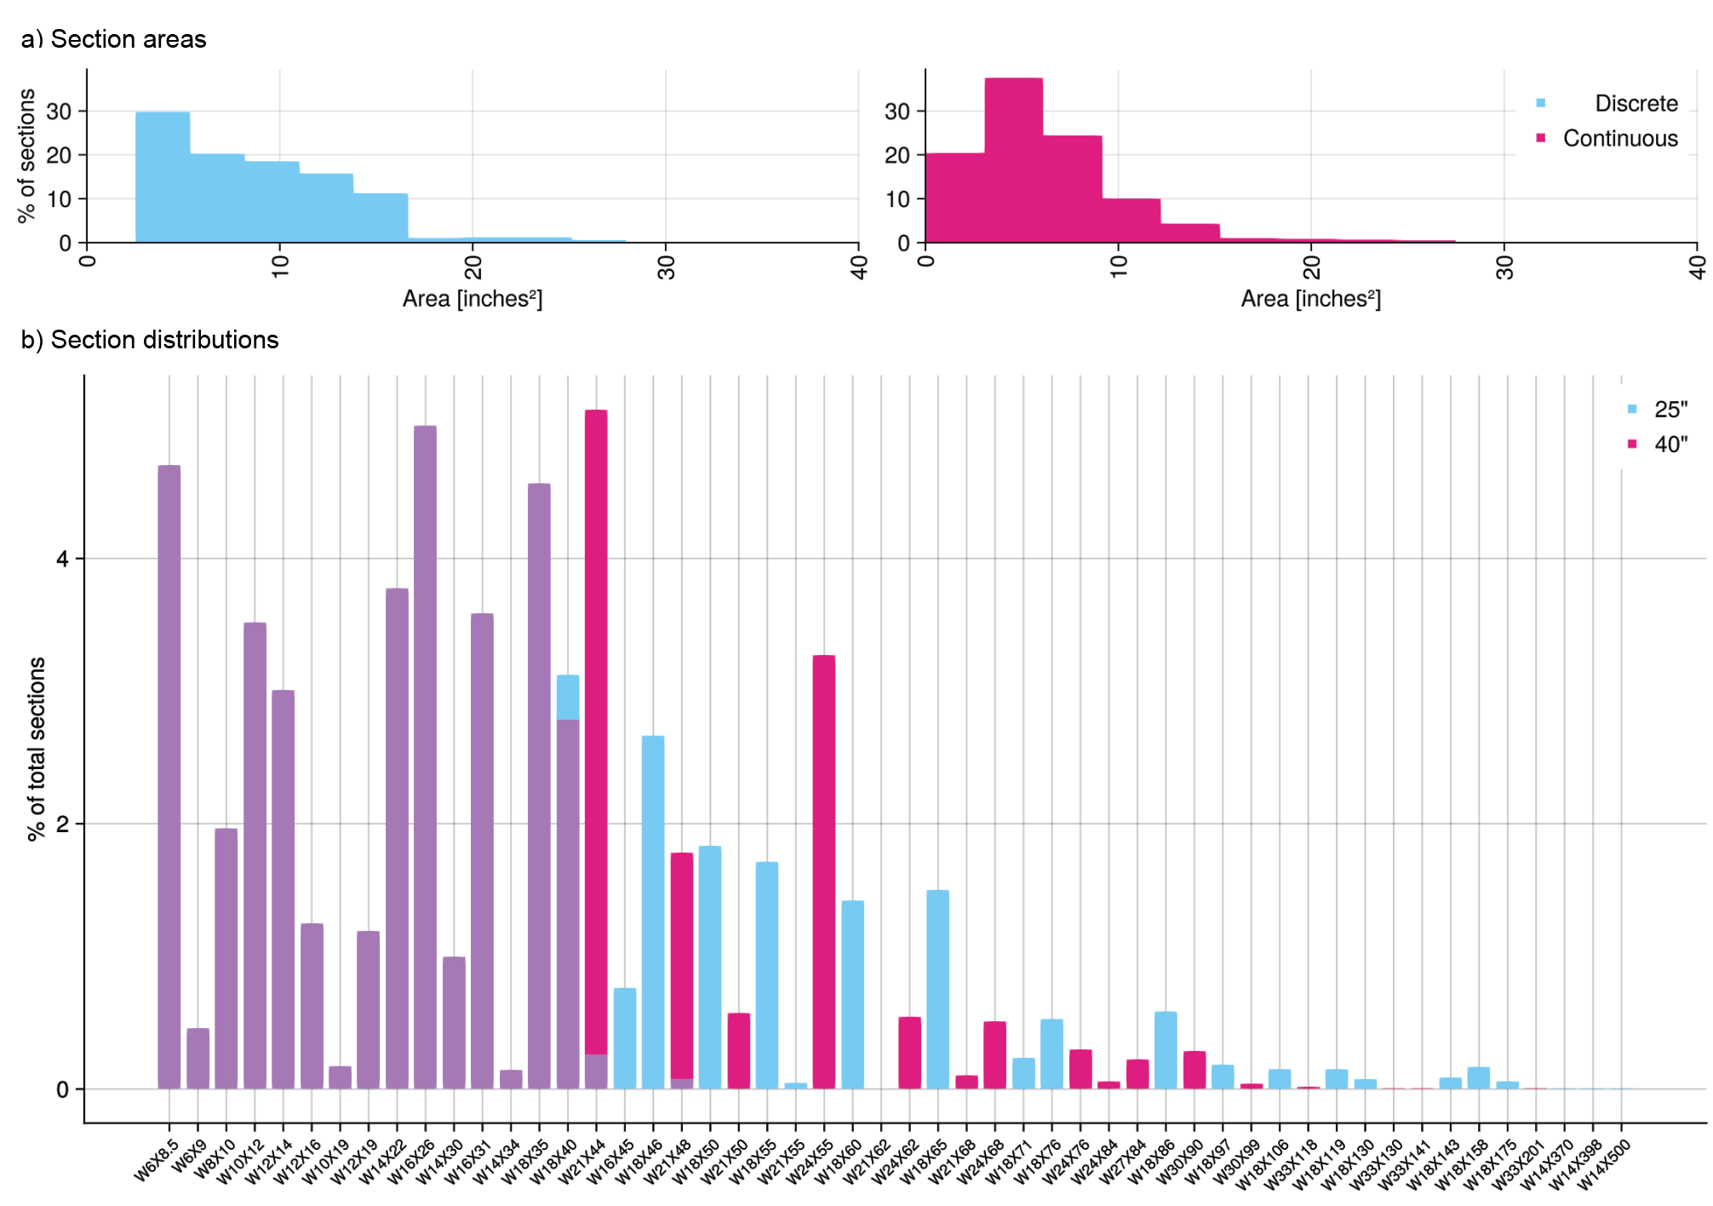

*Figure @: a) the section areas of the beams are greater when sized a discretely (left) than when sized continuously (right) for slabs with a maximum assembly depth of 40”. The total number of sections is 146264 across 1992 slabs; b) the distribution of discrete section sizes over the topology layout set for different assembly depths.*

### 3.1.3 Beam collinearity

Collinearity has a similar, though less pronounced effect on beam efficiency as beam sizing (3% reduction across all slabs). Aligning the sections of all collinear slabs to the largest in each respective sequence adds additional material, increasing the overall steel EC of the slab. The convenience of using larger, monolithic beams rather than moment connections to support the multiple section sizes likely outweighs the marginal efficiency gain. At times, minor inconsistencies in the orientation of a beam will cause a beam to be sized smaller than the surrounding slabs.

### 3.1.4 Assembly depth

Assembly depth can have a significant impact on slab efficiency. Deeper beams are better able to resist moment and shear, though it may be architecturally undesirable if a certain floor height is required, or to save costs. We see this pattern in figure @, which tests several different assembly depths. Most slabs’ EC decreases as depth increases, but plateau after 40” of allowable assembly depth is reached. It also shows that if a slab is feasible at a shallower depth, the efficiency increases are minimal as depth increases compared to slabs that start with a higher EC. This suggests that a combination of other design choices, such as topology, can yield a slab that spans the same area but requires a much shallower assembly.

*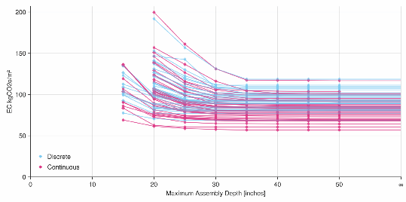Figure @: Embodied carbon for slabs across multiple maximum assembly depths (10”, 15”, 20”, 25”, 30”, 35”, 40”, 45”, 50”, ∞). Slabs with higher embodied carbon are infeasible at lower assembly depths. After an initial reduction in embodied carbon, increasing depth yields low marginal returns.*

The histogram in Figure @b, which is sorted by section area, shows that the distribution of lighter sections chosen for both 25” and 40” assembly depths is almost identical. However, only the 40” assembly depth allows for deeper and lighter sections to be chosen if they are available, leaving a larger number of heavier but shallow sections to be assigned under the 25” assembly depth. A beam layout that uses primarily small beams could have the same efficiency at both assembly depths, which aligns with the results in figure @.

### 3.1.5 Slab types

The final design comparison contrasts different slab types. The isotropic slab often performs best, as the loads are more evenly distributed over the slab. This is especially the case when cells are wide polygons. Geometries that feature long and narrow cells, however, perform better with uniaxial slabs that take advantage of the short spans. Although there are some biaxial orthogonal slabs that perform comparably with the best uniaxial and isotropic cases, the contribution of additional rebar adds up to 10 kgCO2e to the EC of the slab.

The vector orientation of the reinforcement makes a significant difference for certain slabs. This is highlighted in figure @ (megaplot), @, and @ (comparison, and heat maps). Reinforcement direction dictates how much load flows to which beams and which parts of the beams, and determines the maximum span. The latter appears to be especially influential, as can be seen from the presence of horizontal groupings in figure @, where uniaxial slabs with diagonal reinforcement vectors cluster on bands with the same slab EC and are generally distinct from bands featuring vertical or horizontal vectors.

Further, the only slab (t[3,1]) in figure @ whose optimal configuration utilizes a diagonal, uniaxial slab type features a large central diamond shape. Its span is maximized by a uniaxial horizontal vector and minimized by a uniaxial diagonal one. Most remaining slabs have the opposite relationship between vector direction and maximum span. In figure @, the objective landscape, and therefore the position of the optimal slab, changes entirely based on the slab type and vector of reinforcement, with slabs that may be close to optimal for one slab type being far from optimal for another vector.

### 2.1.6 Slab designs

Between the topology, grid, and star datasets, the grid outperforms alternative designs (figure @). Dense grids in particular, such as g[6,6] and g[6,5], have very low EC slabs and steel layouts. These slabs resemble waffle slabs, which have historically been used to remove material from concrete slabs while retaining stiffness by casting regular divots into the slab.[30] Here, the efficiency gains are likely driven by the small maximum spans which yield shallow slabs, and therefore weigh less. Grid slabs with lower density or long strips, like g[1,3], perform poorly depending on the orientation of reinforcement. We see a similar phenomenon amongst the topology slabs, where the dense distribution of t[9,4] leads to a very low slab EC. However, since the layout is less efficient than a grid, its steel EC is not correspondingly low.

The parametric design space of the star slabs overlaps with that of the topology slabs, with a dense distribution around the star-like layout in the topology slab t[6,4]. Exploring the design space revealed other, similar layouts that outperform it (e.g. s[4,5]).

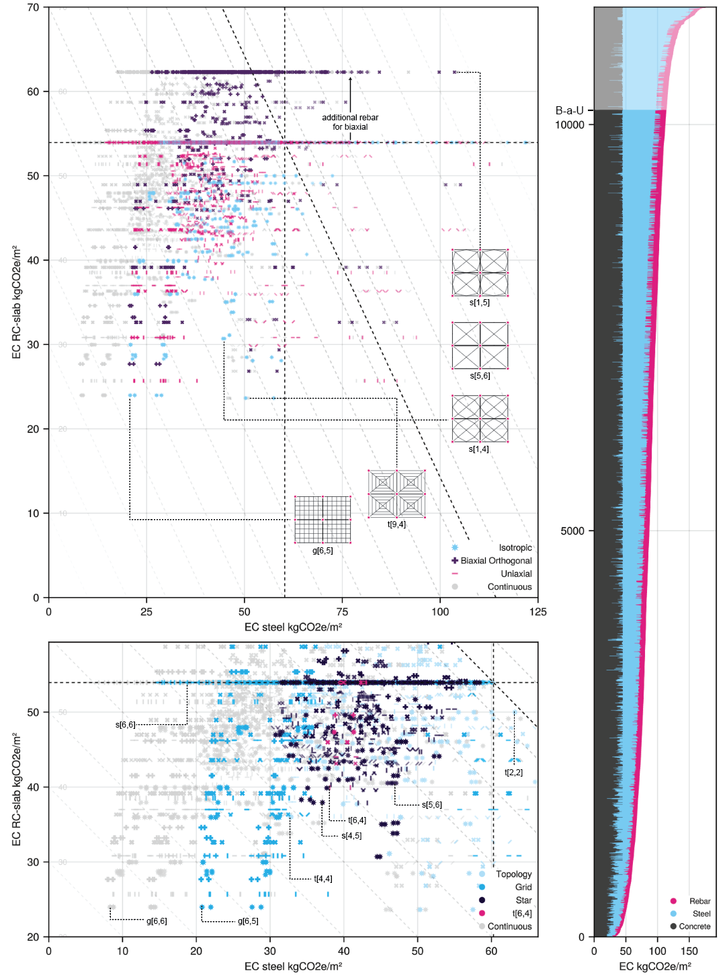

Figure @: Plot showing all analyzed layouts with respect to business-as-usual (B-a-U).

## 3.2 Topologies

In addition to design decisions, slab efficiency is dictated by the topology of the beam layout. This section systematically analyzes a range of discrete geometries and compares their efficiency under combinations of different design decisions. Further, while several precedents’ have demonstrated the potential savings of shaped concrete slabs (section 1), few have concerned themselves with the optimal geometry for a beam-and-grillage system, whose three-dimensional shape is less flexible than a continuously poured slab in formwork.

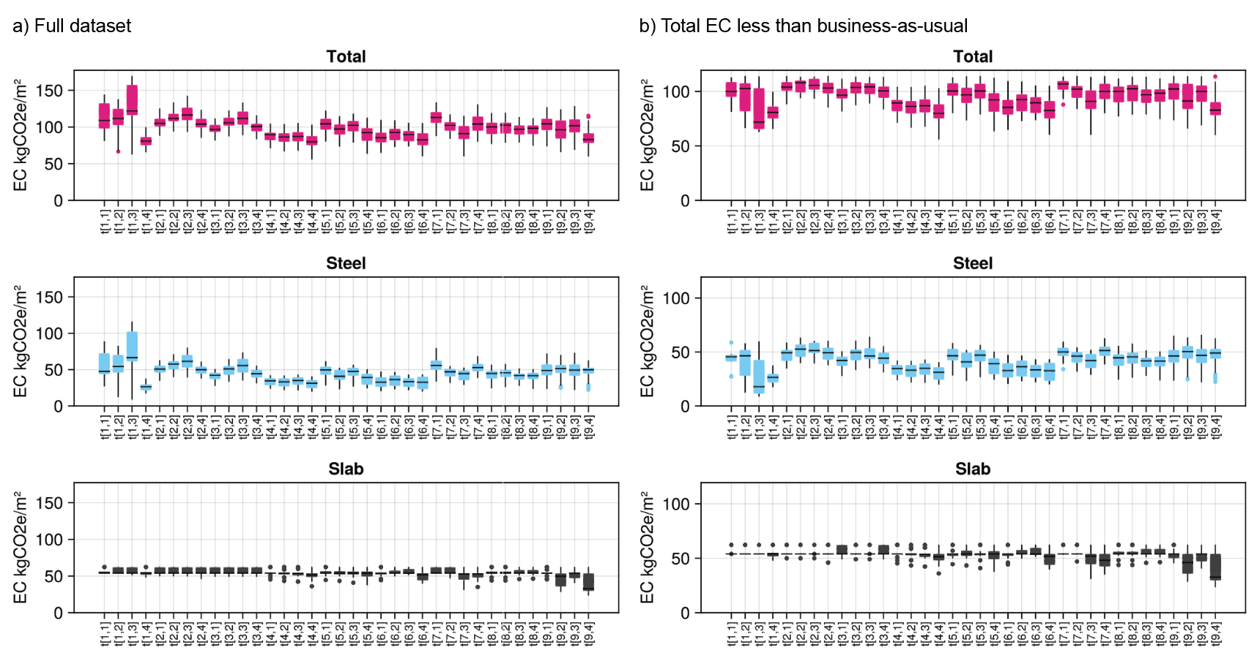

*Figure @:* *Box-and-whisker plots showing the a) summary (11446 slabs) and b) performance-filtered (8650 slabs) results by individual slab.*

While the results in figure @ showed only marginal possible improvement between pairs of design decisions, there is significant variation between layout topologies (figure @). Although steel EC tends to correlate strongly with the total performance of the slab, a low slab EC can offset the effects of high steel EC, as seen in slab t[9,4]. The standard deviation of steel also significantly exceeds that of the slab, suggesting that while slab thickness and EC contribution remains approximately similar, the distribution of supporting beams can have a large effect on overall efficiency.

Figure @ shows all 36 of the topology slabs, sorted by lowest EC achievable using the available design decisions. The grey bars show the EC carbon slab for that topology, highlighting the possible variance. The decisions are indicated using three-letter codes that stand for pairwise combinations, alongside a numerical value denoting the maximum assembly depth and a symbol showing the slab type. For instance, slab t[1,3] has the fifth lowest EC in the dataset if uniaxial along the (1.,0.) vector (—), cellular (c), continuous (c), noncollinear (n), and with a maximum depth of 40” (ccn40). By contrast, t[4,4], which has the lowest EC in the dataset when the same combination of design decisions (ccn40) is used, almost doubles in EC when biaxial orthogonal along the (1.,0.) vector (+), uniformly sized (u), catalog (W), collinear (c), with a maximum depth of 25” (uWc25).

The best performing slabs tend to have beams running both in the x and y directions in the center of the bays (e.g. t[4,4], t[7,3]), along with a diagonal connection to the corner columns. Less successful slabs have beams connecting to the centers of the primary beams instead of the corners (e.g. t[2,3], t[2,2]). In general, higher density of steel beams tends to yield more efficient slabs since the concrete slab is thinner, but this only works until the minimum slab depth of 0.125m is reached, after which the benefits plateau.

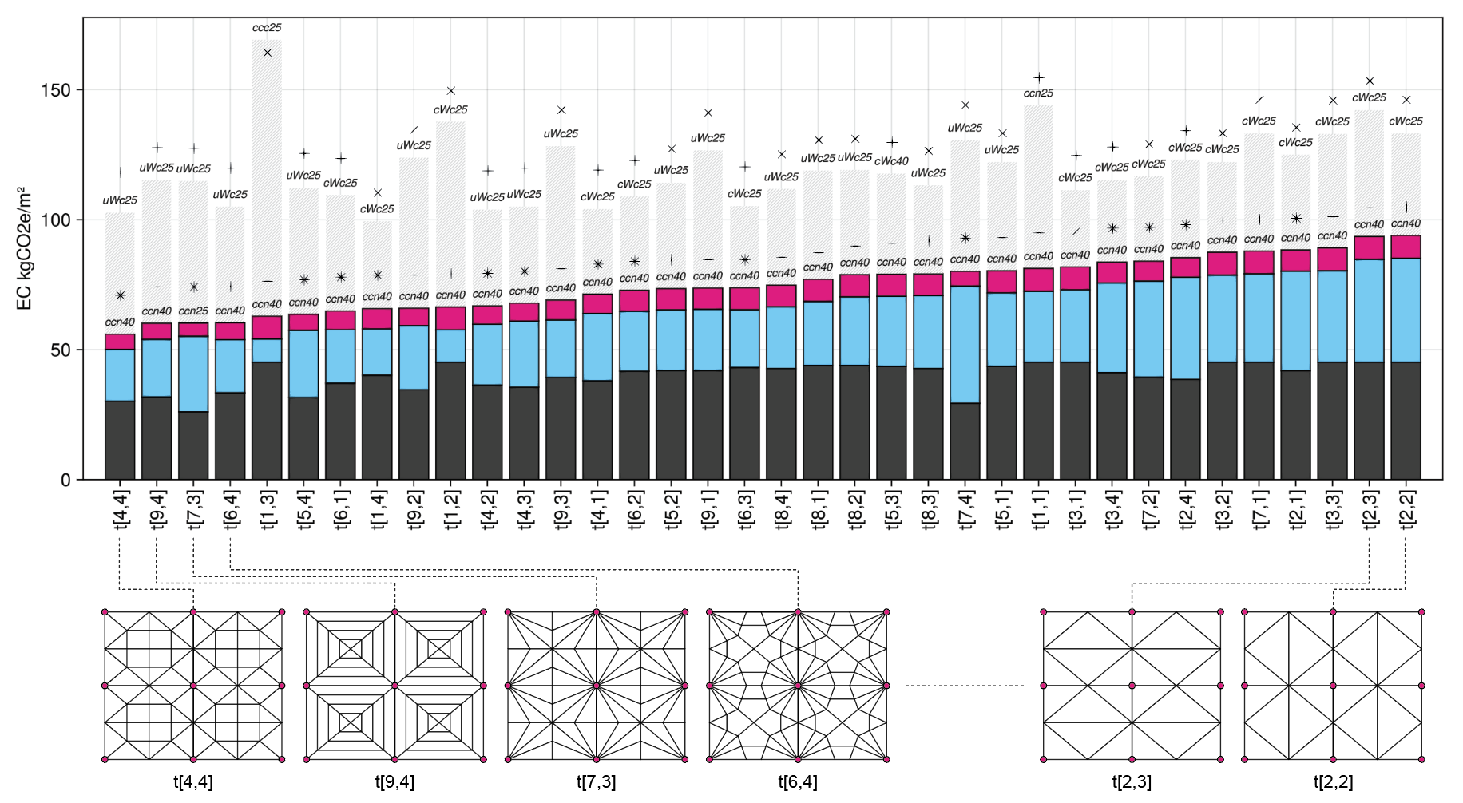

To further investigate the effects of density and geometry, two slab typologies were selected for parameterization: the grid (“g”) and the star (“s”). By changing the parameters of the topology, we are able to explore the design space and determine what decisions are productive and which are not. Figure @a, below, renders the design space of the total EC of the g slabs when isometric, uniform, discrete, noncollinear, and with a maximum assembly depth of 25” (✵ uWn25). As we might expect, as density increases, EC decreases, with a plateau as densities reach their maximum value. When we take sections across the diagonals of the design space (Figure @b), we see that the proportion of EC owing to concrete remains approximately constant, whereas that for steel increases at the corners of the design space. For the isotropic design space, maximum spans will remain the width (g[1,6]) and length (g[6,1]) of the slab, even as the density of spanning beams increases in the corners. The volume of steel rises even as the volume of concrete remains the same, leading to a superfluous and inefficient use of steel. This is particularly the case when the beams are sized discretely and are subject to a minimum section size.

The heat map in figure @c shows how the design space changes in plan as different design decisions are made. Changing the uniaxial slab orientation has a significant effect on the optimal layout, as reinforcement orthogonal to the perimeter of the slab creates a one-dimensional slope toward slabs of higher density, whereas diagonal reinforcement forms a design space resembling the bowl of the isometric slab. Why is the bowl flipped horizontally?

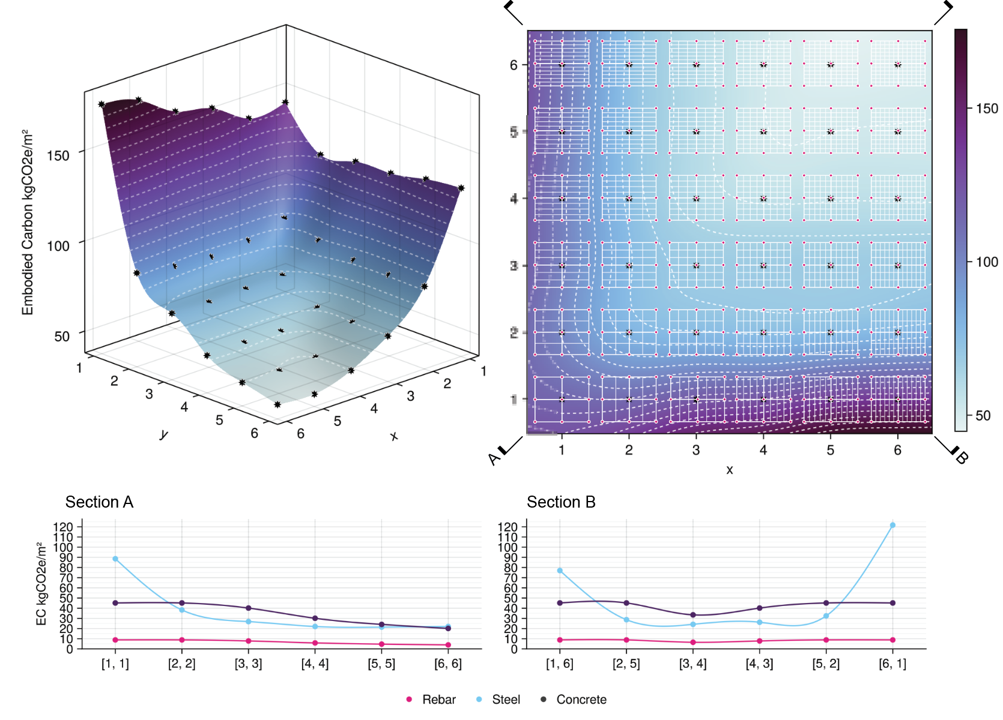

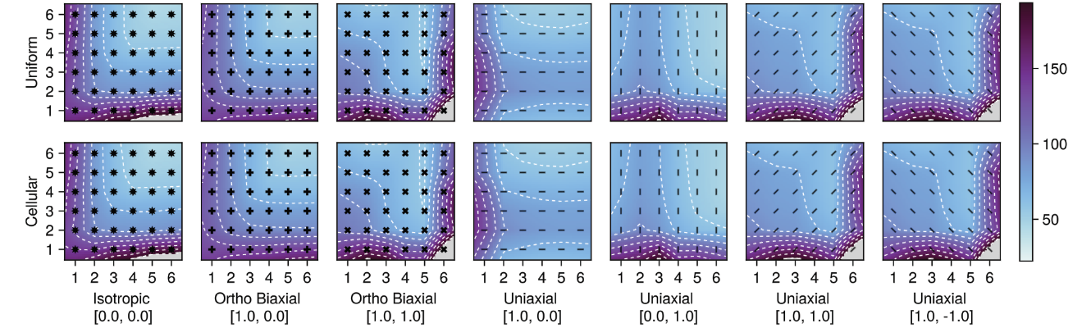

The design space of the star layouts is less smooth. The best geometry in the space is s[4,1], which, in addition to the base x-bracing of the design space, features a cross of secondary beams in the x- and y- directions. The additional diagonal members that form the star intersect the secondary beams approximately halfway between the primary beam and the center of the star. Slab s[4,1] is very similar to t[7,3], the third best overall topology in the manually designed space, though the x-parameter is slightly higher, causing a sharper star shape.

We can see from figure @ that a pure cross-support is not desirable, as it forms a band of poorly-performing slabs where the designs collapse into the same geometry at y=6. A Nervi style slab at [4,3] performs well but is improved by consolidation of beams into a single cross, as in y=1. Beams that are too close together become redundant and are undesirable both from an efficiency and a manufacturing standpoint.

From the heatmaps in Figure @c, we see that a number of layouts are infeasible for an uniaxial slab reinforced in the (1.,0.) direction. Otherwise, uniaxial slabs perform approximately similarly irrespective of orientation when slabs are sized cellularly, with a smaller range of good slabs when constrained by uniform slab sizing. The biaxial orthogonal slabs reinforced along the diagonals have a similar design space as the isotropic slab, though are shown with higher EC due to the additional reinforcement.

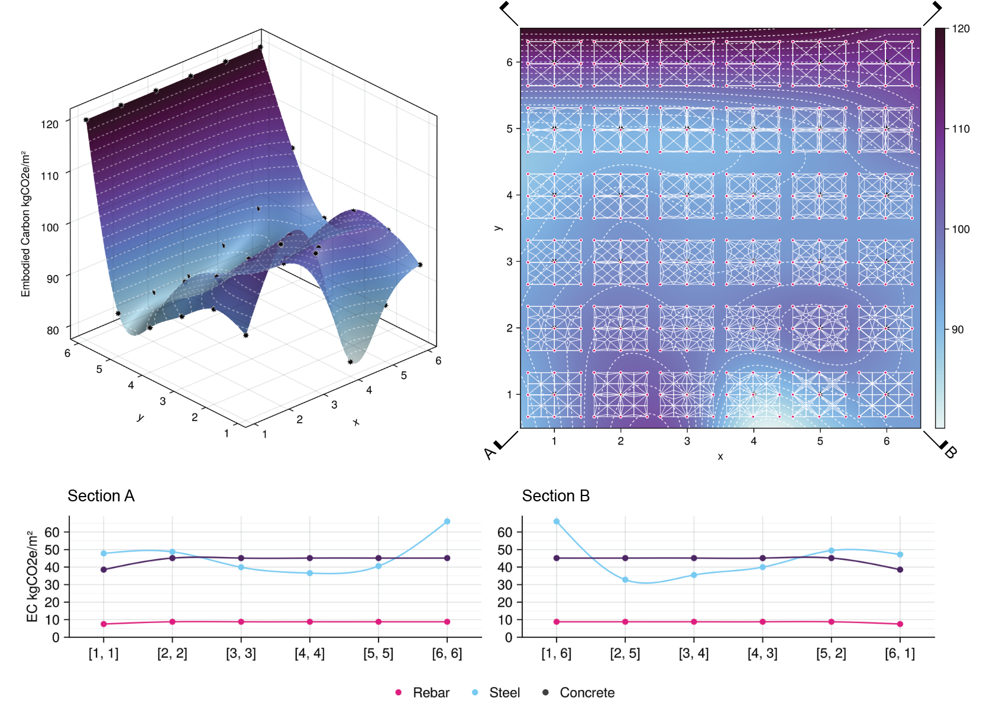

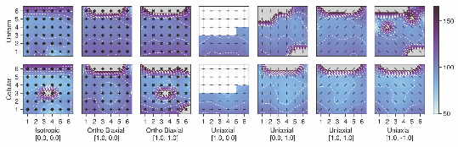

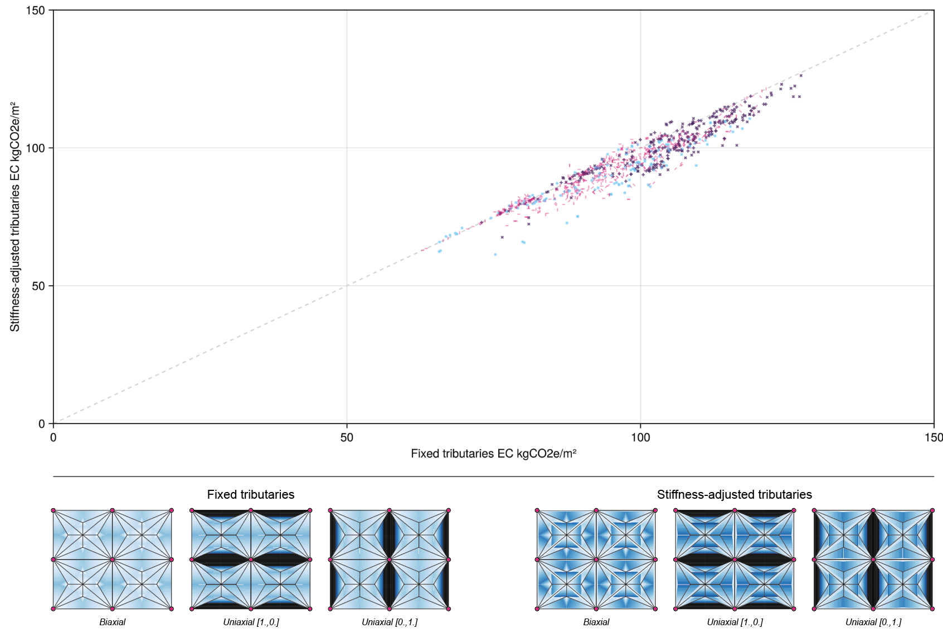

Figure 6:

@ discuss

One limitation of the results presented in this paper, assume lines of the distribution are divided in half, how would you do it alternatively + move the discussion down

## 3.3 Design example: moment releases

As an illustration of the architectural potential of this method, we designed a larger 20x36m office space using the methods outlined. The chosen topology is t[4,4], which was shown to be the most efficient overall topology in the sample set. Initial sizing produced a slab with large variations in beam depth between at key five-way joints. Already a complicated connection, the size of the connecting member makes a moment connection difficult if not impossible. To resolve this issue, the moment connections at these joints were released to make them into shear connections, which created a more reasonable gradation from small sections to large sections.

|  |  |  |  |
| --- | --- | --- | --- |
|  | **Slab [kgCO₂eq/m²]** | **Steel [kgCO₂eq/m²]** | **Total [kgCO₂eq/m²]** |
| **BAU unreleased** | 46.23 | 53.95 | 100.19 |
| **BAU released** | 46.23 | 53.04 | 99.28 |
| **t[4,4] unreleased** | 46.04 | 32.95 | 78.99 |
| **t[4,4] released** | 46.04 | 39.03 | 85.07 |
| **t[4,4] correct** | 46.04 | 43.88 | 89.92 |

The average embodied carbon of the steel increased substantially as a result, rising from 29.8 kgCO2e/m2 to 40.07 kgCO2e/m2. This equated to an increase in total slab embodied carbon from 75.85 kgCO2e/m2 to 86.11 kgCO2e/m2. This is still less than the business-as-usual case, which requires 46.86 kgCO2e/m2 for its steel and 100.8 kgCO2e/m2 across the total slab when using a fully moment-connected frame. @

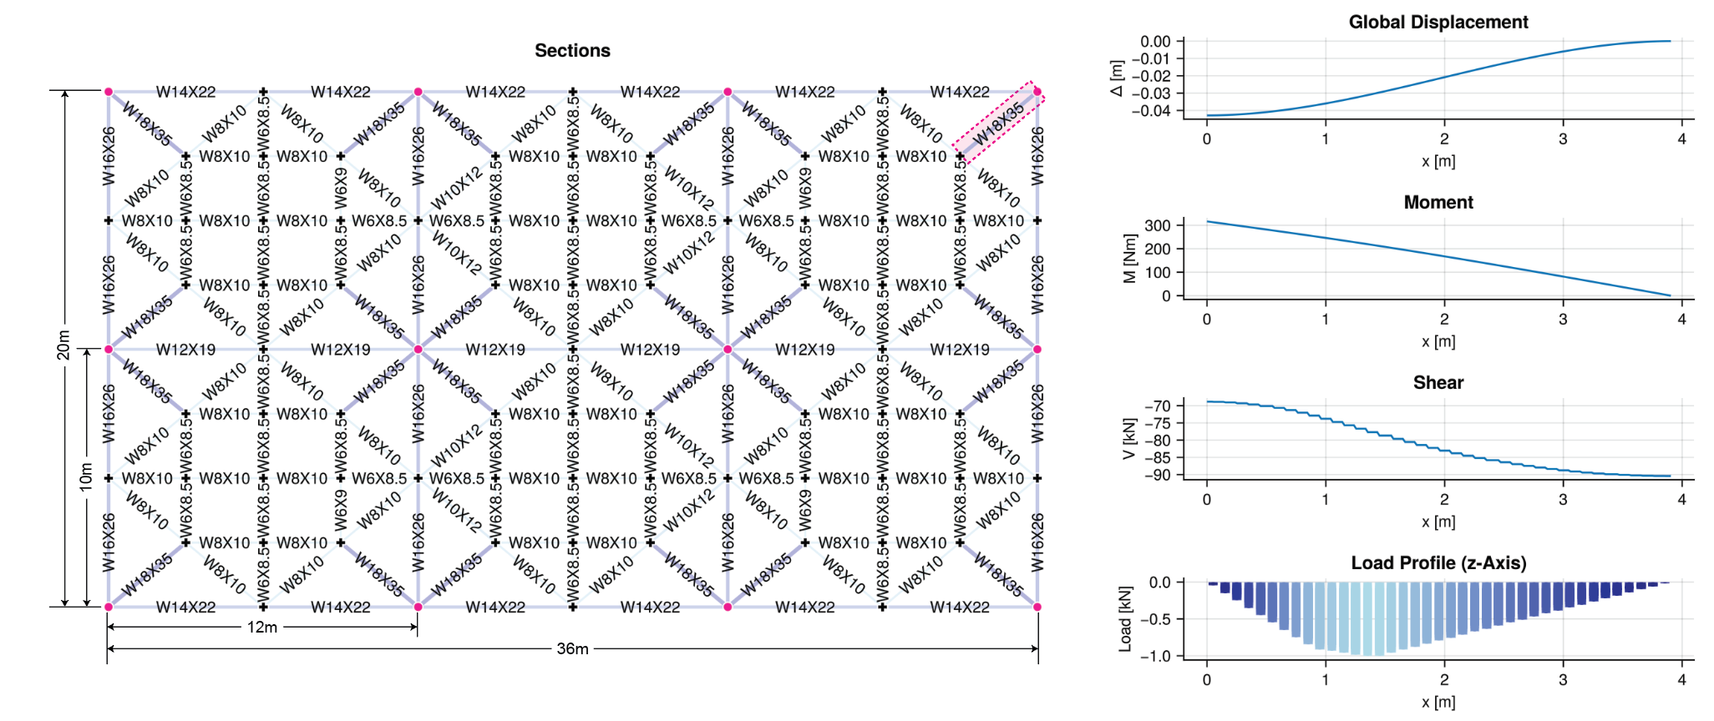

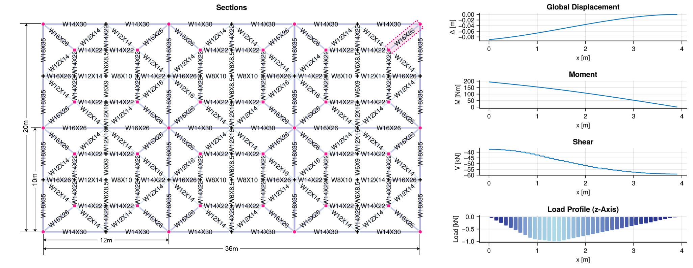

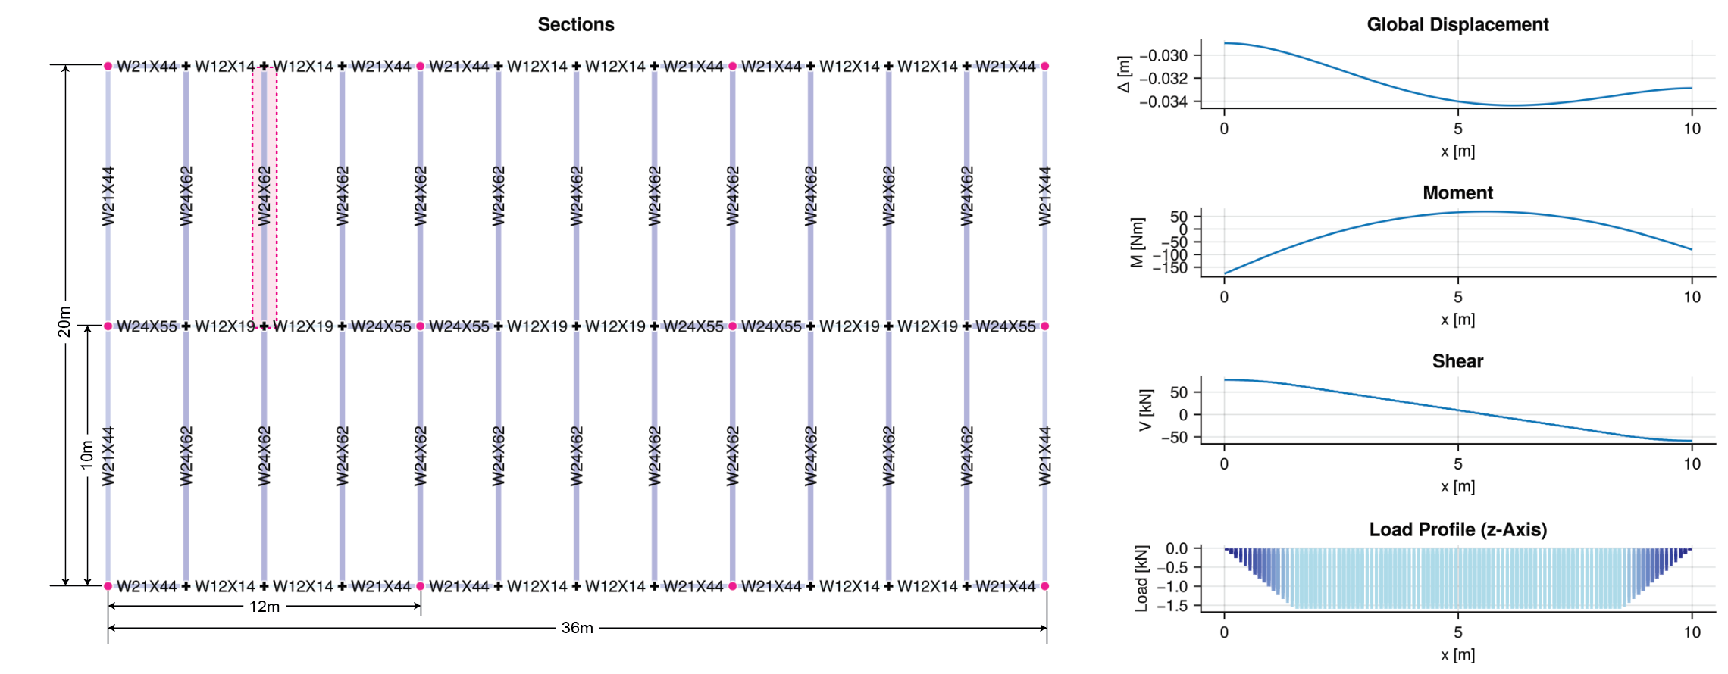

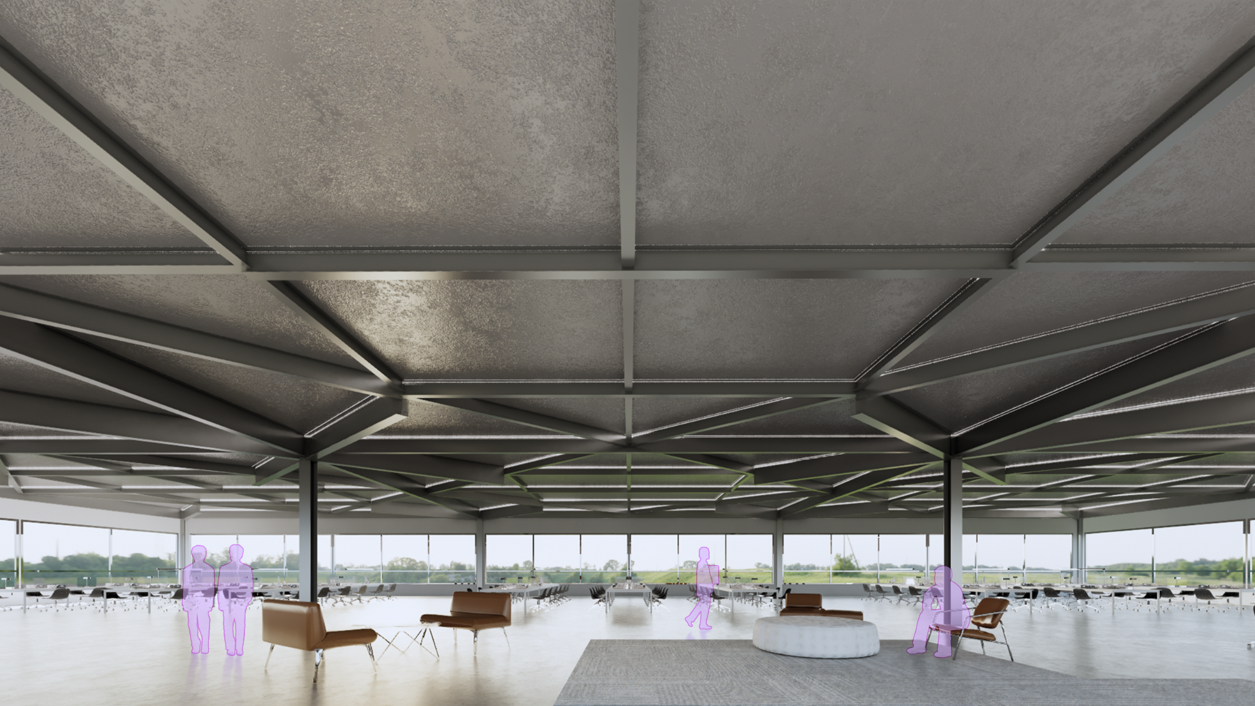

## 3.4 Discussion

- bands of improvement

- constructability

- comparison to higher fidelity models + composite beams

# 4. Conclusions

The purpose of this paper is to accurately model and evaluate the impact of different topology and detailing decisions on the embodied carbon of steel-and-concrete floor systems. Flexural systems account for a significant portion of the total embodied carbon of a building.[2] A numerical analysis across 12096 unique floor slabs suggests that there is significant potential for reducing the embodied carbon of these systems by up to 68.8% if all the design and layout decisions explored here are leveraged, and 42.7% if conventional construction methods are used. To perform this analysis, the paper outlines a novel method for rapidly designing, comparing, and optimizing complex, code-compliant floor layouts for buildings.

## 4.1 Summary of contributions and findings (3-4 paragraphs)

The contributions of this research can be summarized as follows:

* Findings show that EC is generally sensitive to both large-scale design decisions (topology) as well as smaller-scale detailing choices such as rebar layout, slab orientation, and target assembly depth. This is important because it opens accessible yet impactful levers for EC reduction that are compatible with today's materials, construction technologies, and building codes. Topology changes have a more pronounced effect than individual detailing choices, but the greatest efficiency increases can be achieved by combining large- and small-scale slab design decisions.
* By testing more experimental design approaches like finer gradation of slab depths and beam sizes, we can evaluate whether it would be worth pursuing them as construction technologies from a carbon perspective. Increased automation and digital fabrication may make these approaches cost effective in the future, even if they would be cumbersome and costly with today's construction approaches. The results suggest modest carbon benefits on the order of 4-10%, although the savings are higher for designs with overall worse performance. For designs better than business-as-usual, these techniques do not produce sufficient savings to justify their complexity. In other material systems, especially reinforced concrete beam-slab systems, the cost/benefit tradeoff would likely be more favorable.
* Unconventional topologies can reduce embodied carbon from the status quo by over 40%, even without integrating the construction complexities of fine grain slab and beam sizing discussed above. The absolute best designs require an isotropic rebar layout which would be geometrically complex and cast in place. However, uniaxial slabs closely approach the isotropic outcome and could be manufactured with precast planks.
* As non-orthogonal beam-beam connections are already easily achieved by steel fabricators today, these topologies could be cost competitive with business-as-usual construction. It is noteworthy that they tend to have more smaller members in comparison with typical layouts, which require more connections but lighter lift loads. It is likely that some degree of pre-assembly of these layouts could improve construction efficiency and costs.
* Assembly depth is often a decisive constraint in beam-slab layouts. Relaxing this constraint can reduce carbon but at the expense of tighter floor heights, higher facade costs, and challenges with zoning height restrictions. The results presented here show that with better topologies, shallow assembly depths can still produce highly carbon-efficient designs, allowing for the best of both worlds.

## 4.2 Potential impact (1 paragraph)

Beam floor layouts have long been designed using traditional topologies. In part, this owes to a technological constraint, for engineers’ ability to quickly size and iterate over complex beam layouts is limited by software and cost, and in part to a cultural constraint, as unfamiliar design methods are often, and understandably, subject to skepticism. The method above presents a rapidly deployable, automated, and code-compliant strategy that naturally extends conventional beam sizing methods (tributary area and strip analysis) to previously understudied topologies, and simultaneously opens up a range of design decisions for analysis and consideration.

The practical capabilities for installing efficient slab topologies already exist. Modern materials and construction methods, which allow for sophisticated and rigid connections between steel elements and the casting of slabs with a specific reinforcement orientation, can be used to build the layouts presented here. The potential savings of such a choice are up to @%. Multiplied over an entire structure, or an entire city of structures, this could put a substantial dent in the embodied carbon of new development at minimal additional cost.

## 4.3 Limitations and future work

The work presented here is specific to slab-and-beam layouts using RC and hot-rolled steel. There are, however, a multitude of different slab types, materials, and construction methods used to manufacture floor slabs. Further investigation accounting for the mechanics and mechanical specificities of alternative materials would be required to assess whether these layouts are universally efficient, or unique to the case presented here. Materials such as concrete or wood would allow variable beam sizing that is not realistically possible with steel, which could lead to the emergence of compelling architectural geometries.

The present algorithms, while following standard practice procedures, do not fully represent the composite action between beam and slab. Future work would focus on improving the mechanical analysis as well as expanding the scope of the geometry which the algorithm is able to process to include nonconvex perimeters.

Additionally, the detailing decisions are currently made without considering manufacturing constraints, nor is there an EC penalty for using additional formwork. A holistic analysis of the environmental impact and practicality of a floor slab would include these elements.

Finally, the geometries tested here were manually designed, even if parametric. A goal would be to leverage the tributary analyses developed here as subroutines in a topology optimization script that finds the optimal beam layout for different slab geometries automatically.

## 4.4 Concluding remarks

The building industry is caught in a dilemma between the environmental cost of increasing construction and the demand for more housing. There is a pressing need for carbon-reduction strategies that can be rapidly implemented, and strategies for building more efficiently with available construction materials, existing manufacturing techniques, and minimal additional labour can be implemented more rapidly than alternative approaches.

A future, carbon-conscious world requires tools with which engineers and architects are enabled to design low-carbon structures. In this paper, we have presented a better, rapidly deployable, and automated code-compliant method for calculating load distributions and sizing beam layouts that generalizes existing, well-understood analysis methods to complex and novel geometries. Large-scale simulations have shown that topology changes can have a significant impact on the efficiency of a floor slab, especially in combination with detailing decisions around slab sizing, beam sizing, and assembly depth. Multiplied by all the floor slabs in a building, such a design could almost halve the embodied carbon of a building’s structural system, and should be considered when developing new, novel structures.

# A.1 Layout chart

Figure @:

# A.2.1 Results table

|  |  |  |  |  |  |  |  |  |
| --- | --- | --- | --- | --- | --- | --- | --- | --- |
| **Design choice** | **Variation** | **Mean /** kgCO2/m2 | | | **Standard Dev /** kgCO2/m2 | | | **Slab count** |
| *Steel* | *Slab* | *Total* | *Steel* | *Slab* | *Total* |
| Slab depth | Uniform (u) | 39.51 | 52.78 | 92.30 | 17.22 | 8.27 | 20.79 | 5716 |
| Cellular (c) | 38.95 | 49.63 | 88.58 | 17.16 | 8.45 | 20.97 | 5730 |
| Beam sizing | Catalog (W) | 44.20 | 51.20 | 95.41 | 15.03 | 8.51 | 19.12 | 5726 |
| Continuous (c) | 34.26 | 51.21 | 85.47 | 17.77 | 8.51 | 21.54 | 5720 |
| Beam collinearity | Collinear (c) | 40.78 | 51.21 | 91.99 | 16.76 | 8.51 | 20.42 | 5723 |
| Noncollinear (n) | 38.68 | 51.21 | 88.89 | 17.47 | 8.51 | 21.38 | 5723 |
| Assembly depth | 25” | 41.76 | 51.21 | 92.96 | 19.64 | 8.52 | 23.37 | 5694 |
| 40” | 36.73 | 51.21 | 87.94 | 13.92 | 8.50 | 17.92 | 5752 |
| Slab type | Isotropic (✵) | 41.14 | 47.81 | 88.94 | 19.32 | 8.15 | 23.60 | 1718 |
| Biaxial orthogonal (✚) | 40.44 | 56.26 | 96.70 | 15.74 | 9.30 | 20.97 | 3284 |
| Uniaxial (━) | 38.11 | 49.54 | 87.65 | 17.21 | 6.93 | 19.49 | 6444 |
| Slab type &  vectors | Isotropic | 41.14 | 47.81 | 88.94 | 19.32 | 8.15 | 23.60 | 1718 |
| Biaxial orthogonal (1,0) | 39.67 | 58.28 | 97.94 | 13.92 | 8.24 | 19.62 | 1664 |
| Biaxial orthogonal (1,1) | 41.23 | 54.19 | 95.41 | 17.38 | 9.85 | 22.20 | 1620 |
| Uniaxial (1,0) | 34.36 | 49.87 | 84.22 | 14.25 | 6.81 | 16.85 | 1552 |
| Uniaxial (0,1) | 36.93 | 47.97 | 84.90 | 17.60 | 8.66 | 20.47 | 1646 |
| Uniaxial (1,1) | 40.72 | 50.20 | 90.92 | 18.02 | 5.78 | 19.77 | 1632 |
| Uniaxial (1,-1) | 40.28 | 50.16 | 90.44 | 17.82 | 5.80 | 19.61 | 1614 |
| Slab set | Topology (“t”) | 44.68 | 53.75 | 98.43 | 13.95 | 6.56 | 16.01 | 3984 |
| Grid (“g”) | 35.63 | 47.2 | 82.84 | 23.21 | 10.25 | 27.63 | 3984 |
| Star (“s”) | 37.11 | 52.88 | 89.99 | 8.91 | 6.33 | 11.8 | 3478 |
|  | |  |  |  |  |  |  |  |
| Conventional Construction | | 40.68 | 50.99 | 91.66 | 10.40 | 6.80 | 13.54 | 97 |
| Business-as-usual | | 60.28 | 53.94 | 114.23 | - | - | - | 1 |
|  | |  |  |  |  |  |  |  |
| Total | | 39.23 | 51.21 | 90.44 | 17.19 | 8.51 | 20.96 | 11446 |

*Table @: Mean and standard deviation for all slabs*

# A.2.2 Results table for less than business-as-usual

|  |  |  |  |  |  |  |  |  |
| --- | --- | --- | --- | --- | --- | --- | --- | --- |
| **Design choice** | **Variation** | **Mean /** kgCO2/m2 | | | **Standard Dev /** kgCO2/m2 | | | **Slab count** |
| *Steel* | *Slab* | *Total* | *Steel* | *Slab* | *Total* |
| Slab depth | Uniform (u) | 35.16 | 52.37 | 87.52 | 11.95 | 8.35 | 16.54 | 5030 |
| Cellular (c) | 35.01 | 49.00 | 84.00 | 12.01 | 8.35 | 16.11 | 5146 |
| Beam sizing | Catalog (W) | 40.09 | 50.40 | 90.49 | 10.06 | 8.49 | 14.83 | 4941 |
| Continuous (c) | 30.35 | 50.91 | 81.27 | 11.73 | 8.54 | 16.58 | 5235 |
| Beam collinearity | Collinear (c) | 36.47 | 50.61 | 87.08 | 11.23 | 8.51 | 15.59 | 5039 |
| Noncollinear (n) | 33.72 | 50.72 | 84.44 | 12.53 | 8.52 | 17.09 | 5137 |
| Assembly depth | 25” | 35.27 | 50.41 | 85.68 | 11.76 | 8.55 | 16.47 | 4787 |
| 40” | 34.91 | 50.89 | 85.80 | 12.17 | 8.49 | 16.37 | 5389 |
| Slab type | Isotropic (✵) | 35.94 | 47.01 | 82.95 | 12.03 | 8.36 | 16.61 | 1517 |
| Biaxial orthogonal (✚) | 35.61 | 55.38 | 90.99 | 11.30 | 9.65 | 17.57 | 2733 |
| Uniaxial (━) | 34.61 | 49.42 | 84.04 | 12.25 | 6.97 | 15.24 | 5926 |
| Slab type &  vectors | Isotropic | 35.94 | 47.01 | 82.95 | 12.03 | 8.36 | 16.61 | 1517 |
| Biaxial orthogonal (1,0) | 35.67 | 57.52 | 93.19 | 10.76 | 8.78 | 17.36 | 1400 |
| Biaxial orthogonal (1,1) | 35.55 | 53.13 | 88.68 | 11.85 | 10.02 | 17.49 | 1333 |
| Uniaxial (1,0) | 33.10 | 49.77 | 82.87 | 12.6 | 6.88 | 15.32 | 1502 |
| Uniaxial (0,1) | 33.76 | 47.94 | 81.70 | 12.60 | 8.64 | 16.50 | 1538 |
| Uniaxial (1,1) | 35.95 | 50.04 | 85.99 | 11.74 | 5.80 | 14.20 | 1445 |
| Uniaxial (1,-1) | 35.76 | 50.02 | 85.78 | 11.76 | 5.89 | 14.28 | 1441 |
| Slab set | Topology (“t”) | 40.93 | 53.07 | 94.00 | 10.08 | 6.64 | 11.82 | 3411 |
| Grid (“g”) | 27.49 | 46.14 | 73.63 | 12.75 | 10.23 | 17.80 | 3360 |
| Star (“s”) | 36.71 | 52.71 | 89.42 | 8.56 | 6.27 | 11.24 | 3405 |
|  | |  |  |  |  |  |  |  |
| Conventional Construction | | 40.26 | 50.93 | 91.18 | 10.10 | 6.86 | 13.26 | 95 |
| Business-as-usual | | 60.28 | 53.94 | 114.23 | - | - | - | 1 |
|  | |  |  |  |  |  |  |  |
| Total | | 35.08 | 50.66 | 85.74 | 11.98 | 8.52 | 16.42 | 10176 |

*Table @: Mean and standard deviation for slabs with total embodied carbon less than business-as-usual*

# A.3 Json geometry for t[4,4]

"{

"positions": [

{

"x": 90.0,

"y": -85.0,

"z": 0.0

},

{

"x": 93.0,

"y": -85.0,

"z": 0.0

},

{

"x": 96.0,

"y": -85.0,

"z": 0.0

},

{

"x": 99.0,

"y": -85.0,

"z": 0.0

},

{

"x": 102.0,

"y": -85.0,

"z": 0.0

},

{

"x": 105.0,

"y": -85.0,

"z": 0.0

},

{

"x": 108.0,

"y": -85.0,

"z": 0.0

},

{

"x": 111.0,

"y": -85.0,

"z": 0.0

},

{

"x": 114.0,

"y": -85.0,

"z": 0.0

},

{

"x": 90.0,

"y": -75.0,

"z": 0.0

},

{

"x": 93.0,

"y": -75.0,

"z": 0.0

},

{

"x": 96.0,

"y": -75.0,

"z": 0.0

},

{

"x": 99.0,

"y": -75.0,

"z": 0.0

},

{

"x": 102.0,

"y": -75.0,

"z": 0.0

},

{

"x": 105.0,

"y": -75.0,

"z": 0.0

},

{

"x": 108.0,

"y": -75.0,

"z": 0.0

},

{

"x": 111.0,

"y": -75.0,

"z": 0.0

},

{

"x": 114.0,

"y": -75.0,

"z": 0.0

},

{

"x": 93.0,

"y": -87.5,

"z": 0.0

},

{

"x": 96.0,

"y": -87.5,

"z": 0.0

},

{

"x": 99.0,

"y": -87.5,

"z": 0.0

},

{

"x": 99.0,

"y": -82.5,

"z": 0.0

},

{

"x": 96.0,

"y": -82.5,

"z": 0.0

},

{

"x": 93.0,

"y": -82.5,

"z": 0.0

},

{

"x": 90.0,

"y": -80.0,

"z": 0.0

},

{

"x": 90.0,

"y": -90.0,

"z": 0.0

},

{

"x": 96.0,

"y": -80.0,

"z": 0.0

},

{

"x": 102.0,

"y": -80.0,

"z": 0.0

},

{

"x": 102.0,

"y": -90.0,

"z": 0.0

},

{

"x": 96.0,

"y": -90.0,

"z": 0.0

},

{

"x": 108.0,

"y": -90.0,

"z": 0.0

},

{

"x": 105.0,

"y": -87.5,

"z": 0.0

},

{

"x": 111.0,

"y": -87.5,

"z": 0.0

},

{

"x": 114.0,

"y": -90.0,

"z": 0.0

},

{

"x": 111.0,

"y": -82.5,

"z": 0.0

},

{

"x": 114.0,

"y": -80.0,

"z": 0.0

},

{

"x": 108.0,

"y": -80.0,

"z": 0.0

},

{

"x": 105.0,

"y": -82.5,

"z": 0.0

},

{

"x": 108.0,

"y": -87.5,

"z": 0.0

},

{

"x": 108.0,

"y": -82.5,

"z": 0.0

},

{

"x": 99.0,

"y": -72.5,

"z": 0.0

},

{

"x": 102.0,

"y": -70.0,

"z": 0.0

},

{

"x": 93.0,

"y": -77.5,

"z": 0.0

},

{

"x": 99.0,

"y": -77.5,

"z": 0.0

},

{

"x": 96.0,

"y": -70.0,

"z": 0.0

},

{

"x": 93.0,

"y": -72.5,

"z": 0.0

},

{

"x": 90.0,

"y": -70.0,

"z": 0.0

},

{

"x": 96.0,

"y": -77.5,

"z": 0.0

},

{

"x": 96.0,

"y": -72.5,

"z": 0.0

},

{

"x": 114.0,

"y": -70.0,

"z": 0.0

},

{

"x": 108.0,

"y": -70.0,

"z": 0.0

},

{

"x": 105.0,

"y": -77.5,

"z": 0.0

},

{

"x": 111.0,

"y": -77.5,

"z": 0.0

},

{

"x": 111.0,

"y": -72.5,

"z": 0.0

},

{

"x": 105.0,

"y": -72.5,

"z": 0.0

},

{

"x": 108.0,

"y": -77.5,

"z": 0.0

},

{

"x": 108.0,

"y": -72.5,

"z": 0.0

}

],

"connectivities": [

{

"from": 1.0,

"to": 2.0

},

{

"from": 2.0,

"to": 3.0

},

{

"from": 3.0,

"to": 4.0

},

{

"from": 4.0,

"to": 5.0

},

{

"from": 5.0,

"to": 6.0

},

{

"from": 6.0,

"to": 7.0

},

{

"from": 7.0,

"to": 8.0

},

{

"from": 8.0,

"to": 9.0

},

{

"from": 10.0,

"to": 11.0

},

{

"from": 11.0,

"to": 12.0

},

{

"from": 12.0,

"to": 13.0

},

{

"from": 13.0,

"to": 14.0

},

{

"from": 14.0,

"to": 15.0

},

{

"from": 15.0,

"to": 16.0

},

{

"from": 16.0,

"to": 17.0

},

{

"from": 17.0,

"to": 18.0

},

{

"from": 19.0,

"to": 20.0

},

{

"from": 20.0,

"to": 21.0

},

{

"from": 4.0,

"to": 21.0

},

{

"from": 4.0,

"to": 22.0

},

{

"from": 22.0,

"to": 23.0

},

{

"from": 23.0,

"to": 24.0

},

{

"from": 2.0,

"to": 24.0

},

{

"from": 2.0,

"to": 19.0

},

{

"from": 24.0,

"to": 25.0

},

{

"from": 1.0,

"to": 24.0

},

{

"from": 1.0,

"to": 19.0

},

{

"from": 19.0,

"to": 26.0

},

{

"from": 24.0,

"to": 27.0

},

{

"from": 22.0,

"to": 27.0

},

{

"from": 22.0,

"to": 28.0

},

{

"from": 5.0,

"to": 22.0

},

{

"from": 5.0,

"to": 21.0

},

{

"from": 21.0,

"to": 29.0

},

{

"from": 21.0,

"to": 30.0

},

{

"from": 19.0,

"to": 30.0

},

{

"from": 31.0,

"to": 32.0

},

{

"from": 31.0,

"to": 33.0

},

{

"from": 33.0,

"to": 34.0

},

{

"from": 9.0,

"to": 33.0

},

{

"from": 9.0,

"to": 35.0

},

{

"from": 35.0,

"to": 36.0

},

{

"from": 35.0,

"to": 37.0

},

{

"from": 37.0,

"to": 38.0

},

{

"from": 29.0,

"to": 32.0

},

{

"from": 5.0,

"to": 32.0

},

{

"from": 5.0,

"to": 38.0

},

{

"from": 28.0,

"to": 38.0

},

{

"from": 32.0,

"to": 39.0

},

{

"from": 33.0,

"to": 39.0

},

{

"from": 8.0,

"to": 33.0

},

{

"from": 8.0,

"to": 35.0

},

{

"from": 35.0,

"to": 40.0

},

{

"from": 38.0,

"to": 40.0

},

{

"from": 6.0,

"to": 38.0

},

{

"from": 6.0,

"to": 32.0

},

{

"from": 41.0,

"to": 42.0

},

{

"from": 27.0,

"to": 43.0

},

{

"from": 27.0,

"to": 44.0

},

{

"from": 28.0,

"to": 44.0

},

{

"from": 14.0,

"to": 44.0

},

{

"from": 14.0,

"to": 41.0

},

{

"from": 41.0,

"to": 45.0

},

{

"from": 45.0,

"to": 46.0

},

{

"from": 25.0,

"to": 43.0

},

{

"from": 10.0,

"to": 43.0

},

{

"from": 10.0,

"to": 46.0

},

{

"from": 46.0,

"to": 47.0

},

{

"from": 43.0,

"to": 48.0

},

{

"from": 44.0,

"to": 48.0

},

{

"from": 13.0,

"to": 44.0

},

{

"from": 13.0,

"to": 41.0

},

{

"from": 41.0,

"to": 49.0

},

{

"from": 46.0,

"to": 49.0

},

{

"from": 11.0,

"to": 46.0

},

{

"from": 11.0,

"to": 43.0

},

{

"from": 25.0,

"to": 27.0

},

{

"from": 27.0,

"to": 28.0

},

{

"from": 14.0,

"to": 28.0

},

{

"from": 14.0,

"to": 42.0

},

{

"from": 42.0,

"to": 45.0

},

{

"from": 45.0,

"to": 47.0

},

{

"from": 10.0,

"to": 47.0

},

{

"from": 10.0,

"to": 25.0

},

{

"from": 29.0,

"to": 31.0

},

{

"from": 31.0,

"to": 34.0

},

{

"from": 9.0,

"to": 34.0

},

{

"from": 9.0,

"to": 36.0

},

{

"from": 36.0,

"to": 37.0

},

{

"from": 28.0,

"to": 37.0

},

{

"from": 5.0,

"to": 28.0

},

{

"from": 5.0,

"to": 29.0

},

{

"from": 26.0,

"to": 30.0

},

{

"from": 29.0,

"to": 30.0

},

{

"from": 1.0,

"to": 25.0

},

{

"from": 1.0,

"to": 26.0

},

{

"from": 18.0,

"to": 36.0

},

{

"from": 18.0,

"to": 50.0

},

{

"from": 50.0,

"to": 51.0

},

{

"from": 42.0,

"to": 51.0

},

{

"from": 37.0,

"to": 52.0

},

{

"from": 37.0,

"to": 53.0

},

{

"from": 36.0,

"to": 53.0

},

{

"from": 18.0,

"to": 53.0

},

{

"from": 18.0,

"to": 54.0

},

{

"from": 50.0,

"to": 54.0

},

{

"from": 51.0,

"to": 54.0

},

{

"from": 51.0,

"to": 55.0

},

{

"from": 28.0,

"to": 52.0

},

{

"from": 14.0,

"to": 52.0

},

{

"from": 14.0,

"to": 55.0

},

{

"from": 42.0,

"to": 55.0

},

{

"from": 52.0,

"to": 56.0

},

{

"from": 53.0,

"to": 56.0

},

{

"from": 17.0,

"to": 53.0

},

{

"from": 17.0,

"to": 54.0

},

{

"from": 54.0,

"to": 57.0

},

{

"from": 55.0,

"to": 57.0

},

{

"from": 15.0,

"to": 55.0

},

{

"from": 15.0,

"to": 52.0

},

{

"from": 45.0,

"to": 49.0

},

{

"from": 12.0,

"to": 49.0

},

{

"from": 12.0,

"to": 48.0

},

{

"from": 27.0,

"to": 48.0

},

{

"from": 23.0,

"to": 27.0

},

{

"from": 3.0,

"to": 23.0

},

{

"from": 3.0,

"to": 20.0

},

{

"from": 20.0,

"to": 30.0

},

{

"from": 51.0,

"to": 57.0

},

{

"from": 16.0,

"to": 57.0

},

{

"from": 16.0,

"to": 56.0

},

{

"from": 37.0,

"to": 56.0

},

{

"from": 37.0,

"to": 40.0

},

{

"from": 7.0,

"to": 40.0

},

{

"from": 7.0,

"to": 39.0

},

{

"from": 31.0,

"to": 39.0

}

],

"columns_i": [

25.0,

47.0,

26.0,

29.0,

28.0,

42.0,

50.0,

36.0,

34.0

]

}"

1. Architecture 2030. (n.d.). *Why The Built Environment – Architecture 2030*. Retrieved March 19, 2024, from https://www.architecture2030.org/why-the-built-environment/

2. Foraboschi, P., Mercanzin, M., & Trabucco, D. (2014). Sustainable structural design of tall buildings based on embodied energy. *Energy and Buildings*, *68*, 254–269. https://doi.org/10.1016/j.enbuild.2013.09.003

3. Bischof, P., Mata-Falcón, J., & Kaufmann, W. (2022). Fostering innovative and sustainable mass-market construction using digital fabrication with concrete. *Cement and Concrete Research*, *161*, 106948. https://doi.org/10.1016/j.cemconres.2022.106948

4. Kromoser, B. (2020). *Ressourceneffizientes Bauen mit Betonfertigteilen. Material—Struktur—Herstellung* (pp. 307–356). https://doi.org/10.1002/9783433610206.ch3

5. Iori, T., & Poretti, S. (1960). *Pier Luigi Nervi’s Works for the 1960 Rome Olympics*.

6. Halpern, A. B., Billington, D. P., & Adriaenssens, S. (2013). *The ribbed floor slab systems of pier luigi nervi*. *54*, 127–136.

7. Morley, C. T. (1966). The minimum reinforcement of concrete slabs. *International Journal of Mechanical Sciences*, *8*(4), 305–319. https://doi.org/10.1016/0020-7403(66)90031-2

8. Rozvany, G. I. N. (1976). *Optimal Design of Flexural Systems: Beams, Grillages, Slabs, Plates and Shells* (First Edition). Pergamon.

9. Bolbotowski, K., He, L., & Gilbert, M. (2018). Design of optimum grillages using layout optimization. *Structural and Multidisciplinary Optimization*, *58*(3), 851–868. https://doi.org/10.1007/s00158-018-1930-6

10. Ismail, M. A., Mayencourt, P. L., & Mueller, C. T. (2021). Shaped beams: Unlocking new geometry for efficient structures. *Architecture, Structures and Construction*, *1*(1), 37–52. https://doi.org/10.1007/s44150-021-00003-y

11. Mayencourt, P., & Mueller, C. (2020). Hybrid analytical and computational optimization methodology for structural shaping: Material-efficient mass timber beams. *Engineering Structures*, *215*, 110532. https://doi.org/10.1016/j.engstruct.2020.110532

12. Carruth, M. A., Allwood, J. M., & Moynihan, M. C. (2011). The technical potential for reducing metal requirements through lightweight product design. *Resources, Conservation and Recycling*, *57*, 48–60. https://doi.org/10.1016/j.resconrec.2011.09.018

13. Lee, K. J., Hirt, N. K., & Mueller, C. T. (2024). *Geometry, strength, and efficiency: Tracing the standardization of North American structural steel, 1888-present*. 8th International Congress on Construction History, Zürich.

14. Meibodi, M. A. ; J. (2018). Smart Slab. Computational design and digital fabrication of a lightweight concrete slab. *ACADIA // 2018: Recalibration. On Imprecisionand Infidelity. [Proceedings of the 38th Annual Conference of the Association for Computer Aided Design in Architecture (ACADIA) ISBN 978-0-692-17729-7] Mexico City, Mexico 18-20 October, 2018, Pp. 434-443*. https://papers.cumincad.org/cgi-bin/works/paper/acadia18_434

15. Jewett, J. L., & Carstensen, J. V. (2019). Topology-optimized design, construction and experimental evaluation of concrete beams. *Automation in Construction*, *102*, 59–67. https://doi.org/10.1016/j.autcon.2019.02.001

16. Li, L., Yan, J., & Xing, Z. (2013). Energy requirements evaluation of milling machines based on thermal equilibrium and empirical modelling. *Journal of Cleaner Production*, *52*, 113–121. https://doi.org/10.1016/j.jclepro.2013.02.039

17. Whiteley, J., Liew, A., He, L., & Gilbert, M. (2023). Engineering design of optimized reinforced concrete floor grillages. *Structures*, *51*, 1292–1304. https://doi.org/10.1016/j.istruc.2023.03.116

18. Bradbury, L., Liew, A., & Gilbert, M. (2024). *Applications of optimal reinforcement layouts for concrete slabs via digital fabrication methods*.

19. Nervi, P. L. (1965). *Aesthetics and Technology in Building* (R. Einaudi, Trans.). Harvard University Press.

20. Rippmann, M., Liew, A., Van Mele, T., & Block, P. (2018). Design, fabrication and testing of discrete 3D sand-printed floor prototypes. *Materials Today Communications*, *15*, 254–259. https://doi.org/10.1016/j.mtcomm.2018.03.005

21. Fang, D., Brown, N., De Wolf, C., & Mueller, C. (2023). Reducing embodied carbon in structural systems: A review of early-stage design strategies. *Journal of Building Engineering*, *76*, 107054. https://doi.org/10.1016/j.jobe.2023.107054

22. American Concrete Institute. (n.d.). *ACI 318-19 Building Code Requirements for Structural Concrete*.

23. American Institute of Steel Construction. (2016). *ANSI/AISC 360-16 Specification for structural steel buildings*. https://www.aisc.org/publications/steel-standards/aisc-360/

24. American Society of Civil Engineers. (2023). *ASCE/SEI 7-22 Minimum Design Loads and Associated Criteria for Buildings and Other Structures*. https://ascelibrary.org/doi/10.1061/9780784415788.sup1

25. Lee, K. J. (2023). *aSAP* [Julia]. https://github.com/keithjlee/Asap (Original work published 2021)

26. Palfrader, P., & Held, M. (2015). Computing Mitered Offset Curves Based on Straight Skeletons. *Computer-Aided Design and Applications*, *12*, 414–424. https://doi.org/10.1080/16864360.2014.997637

27. Bertsimas, D., Tsitsiklis, J. N., & Tsitsiklis, J. (1997). *Introduction to Linear Optimization* (unknown edition). Athena Scientific.

28. JuliaOpt. (2024). *NLopt* [Julia]. JuliaOpt. https://github.com/JuliaOpt/NLopt.jl (Original work published 2013)

29. Svanberg, K. (1987). The method of moving asymptotes—A new method for structural optimization. *International Journal for Numerical Methods in Engineering*, *24*(2), 359–373. https://doi.org/10.1002/nme.1620240207

30. Curth, A., Hartwell, A., Brodesser, T., & Mueller, C. (2022, September 19). *Parametric waffle slabs: Optimal geometry materialized with additive construction*.